# Linux Module 1 Exercise

## 1. Creating Users in Linux

• Which command is used to create a new user in Linux?

The `useradd` command is used to create a new user in Linux.

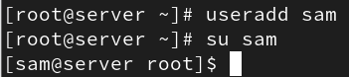

• What is the syntax for creating a user using the useradd command?

Syntax: `useradd [options] username`  
Example: `useradd john`

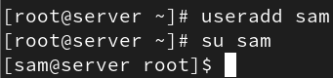

• Can you create a user with specific user ID (UID) and group ID (GID) using the useradd command? If yes, how?

Yes. Use the `-u` option for UID and `-g` for GID.  
Example: `useradd -u 1050 -g 100 denis`

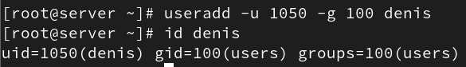

• How can you set an initial password for a newly created user?

Use the `passwd` command.  
Example: `passwd denis`

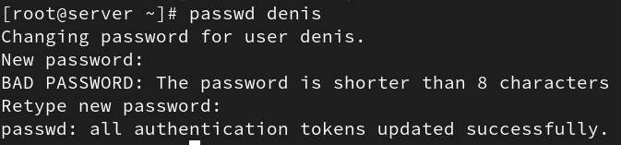

• What happens if you try to create a user with a username that already exists on the system?

The system will display an error message: `useradd: user 'username' already exists`.



• Is it possible to create a user without a home directory? If yes, how?

Yes, use the `-M` option.  
Example: `useradd -M wright`





• How can you specify the shell for a user during creation?

Use the `-s` option.  
Example: `useradd -s /bin/bash noe`

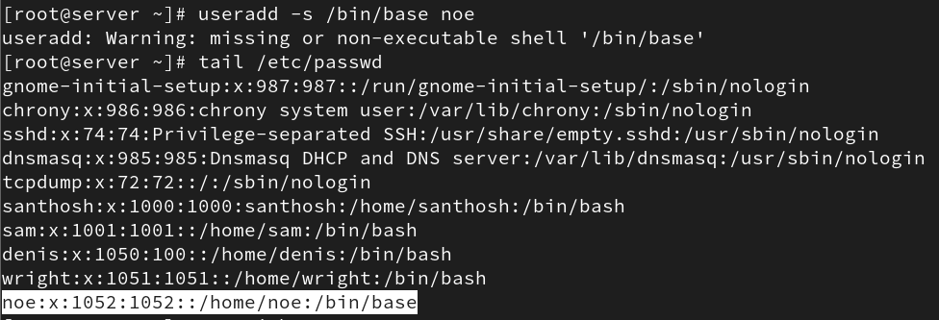

• Can you create a user with additional supplementary groups using the useradd command? If yes, how?

Yes, use the `-G` option.  
Example: `useradd -G wheel,developers fincher`

• How can you verify that a user has been successfully created?

You can check `/etc/passwd` file or use `id username` or `getent passwd username`.



• Is there a way to create a user with a specific expiration date? If yes, how?

Yes, use the `-e` option.  
Example: `useradd -e 2025-12-31 eric







## 2. cat command in Linux

• What is the purpose of the cat command in Linux?

The `cat` command is used to display, combine, and create files.



• How do I use the cat command to display the contents of a file on the terminal?

Use `cat filename`. Example: `cat /etc/passwd`

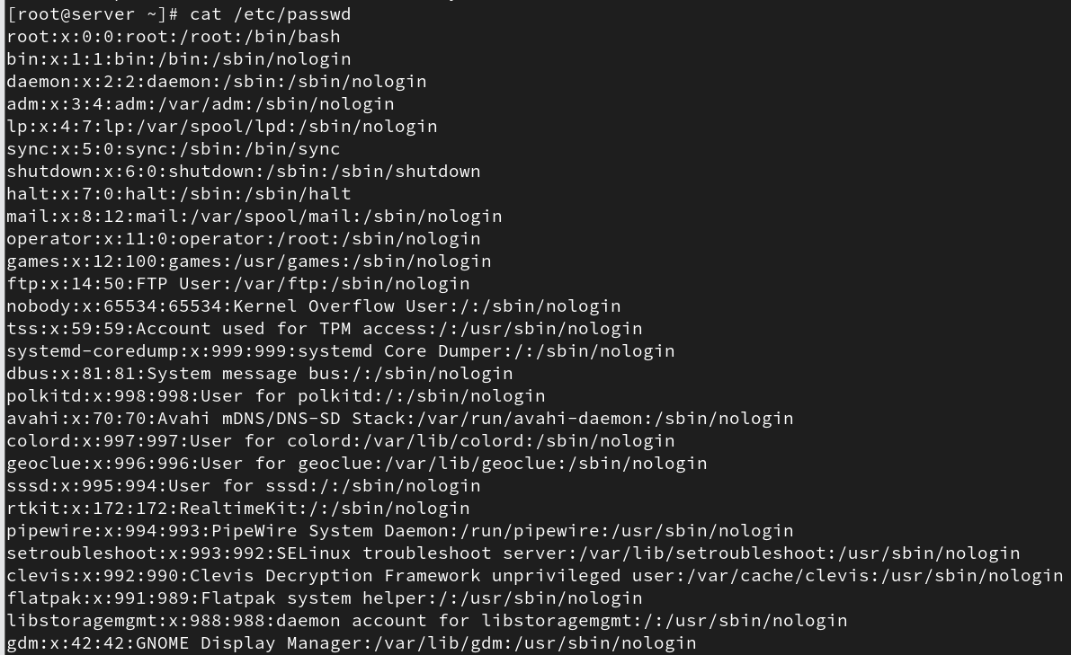

• Can cat display the contents of multiple files at once?

Yes. Example: `cat file1 file2`

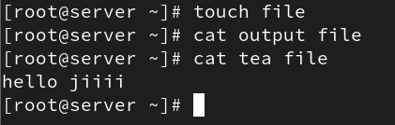

• What are some options available with the cat command, and how do I use them?

`-n` (number lines), `-b` (number non-empty lines), `-s` (suppress blank lines). Example: `cat -n file`

• How can I create a new file using the cat command?

Use `cat > filename` and press Ctrl+D to save.

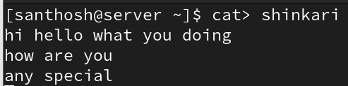

• Is it possible to concatenate multiple files using cat? If yes, how?

Yes. Example: `cat file1 file2 > combined.txt`

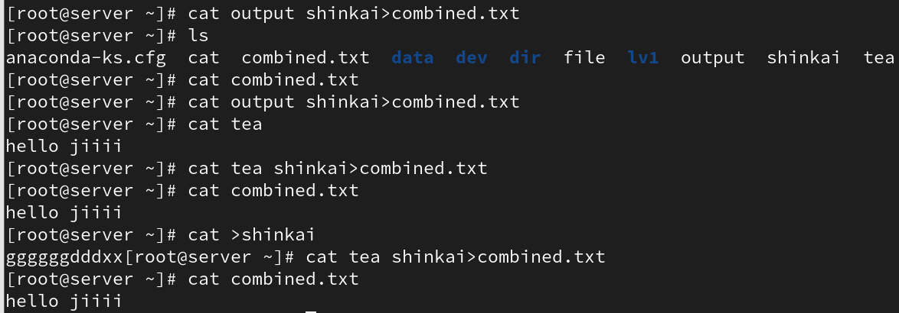

• How does the cat command handle binary files?

`cat` can display binary data, but output may contain unreadable characters.

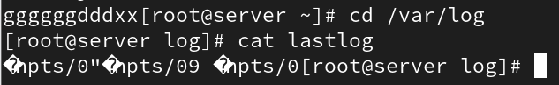

• Can I number the lines while displaying the contents of a file with cat?

Yes, use `cat -n filename`.

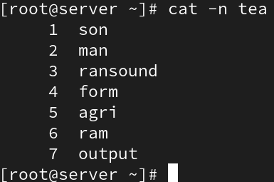

• How do I suppress the display of trailing whitespace in cat output?

`cat` does not natively support this; use tools like `sed` or `awk`.

• Can I use cat to append the contents of one file to another?

Yes. Example: `cat file1 >> file2`

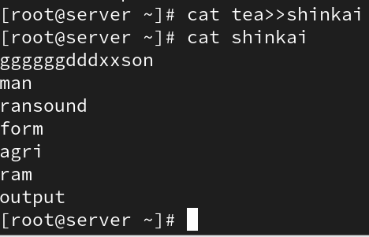

• Is it possible to create a copy of a file using the cat command?

Yes. Example: `cat file1 > file2`

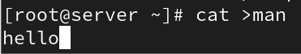

• How can I use cat to display non-printing characters like tabs and newlines as visible characters?

Use `cat -v filename`.

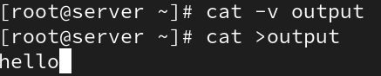

• What happens if I use cat with multiple files, but some of them do not exist?

`cat` will display an error message for missing files but continue with others.

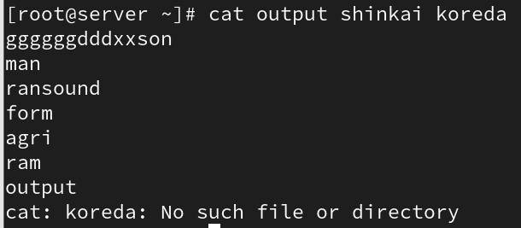

• Can cat be used to view the contents of remote files over SSH?

Yes, by combining with SSH. Example: `ssh user@host cat /path/to/file`

• How does the cat command handle files with very long lines?

`cat` displays them as-is, wrapping may depend on the terminal settings.

## 3. “ls” command in Linux

• What is the purpose of the ls command in Linux?

The `ls` command lists files and directories.



• How do I use the ls command to list files and directories in the current directory?

Use `ls`.



• Can ls display file and directory details, such as permissions, owner, size, and modification date?

Yes, use `ls -l` for long listing format.

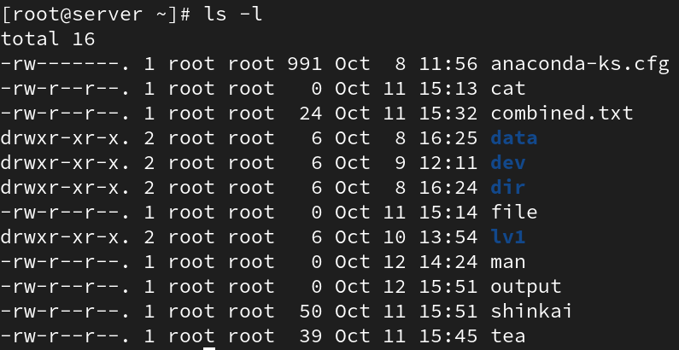

• How can I list files and directories in a specific directory other than the current one?

Use `ls /path/to/directory`.



• What are some common options that can be used with the ls command, and how do I use them?

`-a` (show hidden), `-l` (long list), `-h` (human readable), `-R` (recursive).



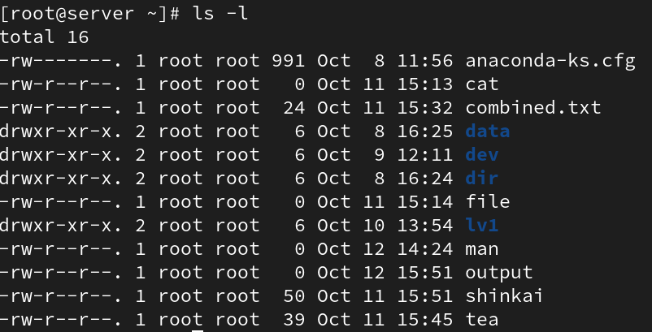

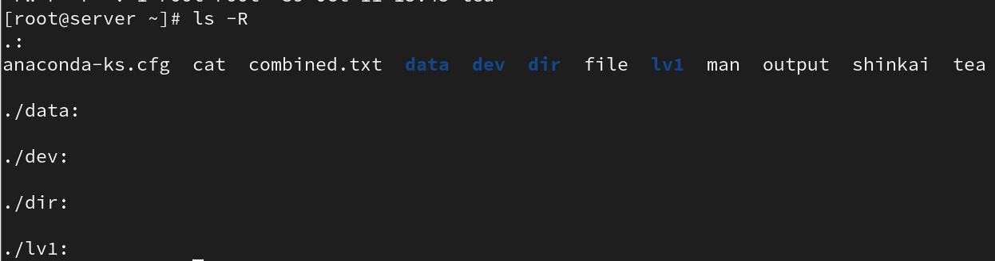



• How can I make ls show hidden files and directories?

Use `ls -a`.



* • Is it possible to list files and directories in a long format with human-readable file sizes?

Yes, use `ls -lh`.

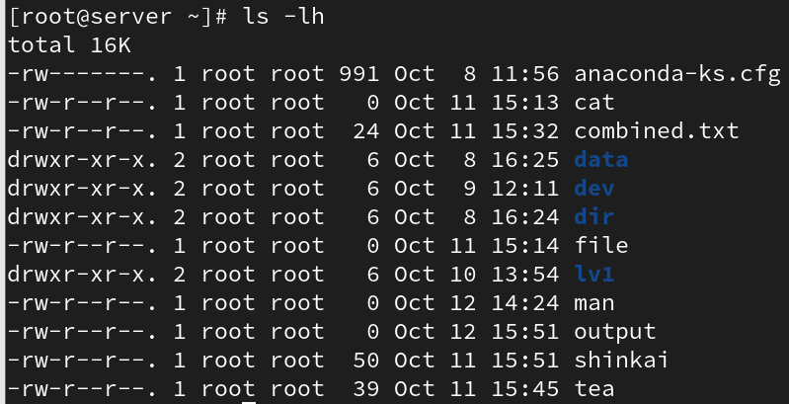

• How do I sort the ls output by different criteria, such as name, size, or modification time?

Use `--sort=size`, `--sort=time`, or `--sort=name`.



• Can ls display files and directories with color-coded output?

Yes, use `ls --color=auto`.



• How can I recursively list files and directories within sub-directories?

Use `ls -R`.

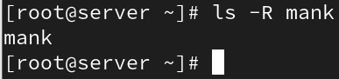

• What is the difference between ls and ls -l in terms of the information they display?

`ls` shows names only; `ls -l` shows detailed info like permissions and size.



• How can I use ls to find files that match a specific pattern or extension?

Use wildcards. Example: `ls *.txt`

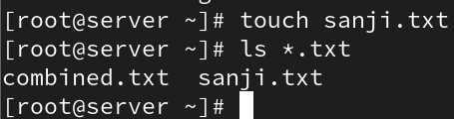

• Can ls display file sizes in units other than bytes, such as kilobytes or megabytes?

Yes, use `ls -lh` for human-readable sizes.

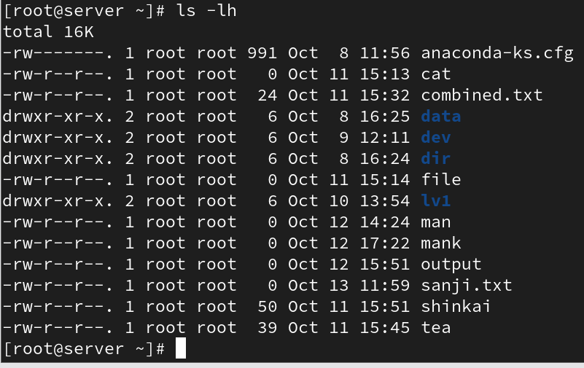

• How do I use ls to list only directories, excluding regular files?

Use `ls -d */`

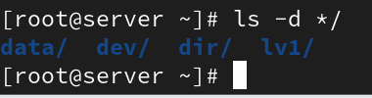

• What happens if I use ls with a directory that I don’t have permission to access?

`ls` will display a 'Permission denied' message for that directory.

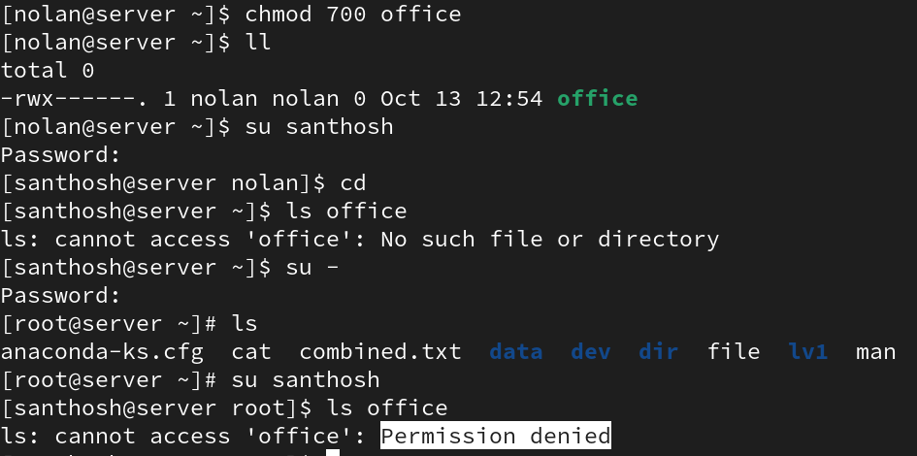

## 4. Creating Directories in Linux

• Which command is used to create a new directory in Linux?

The `mkdir` command.

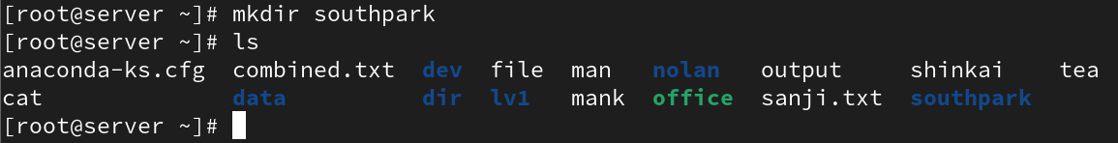

• What is the syntax for creating a directory using the mkdir command?

Syntax: `mkdir [options] directory_name`



• Can you create multiple directories at once using the mkdir command? If yes, how?

Yes. Example: `mkdir dir1 dir2 dir3`

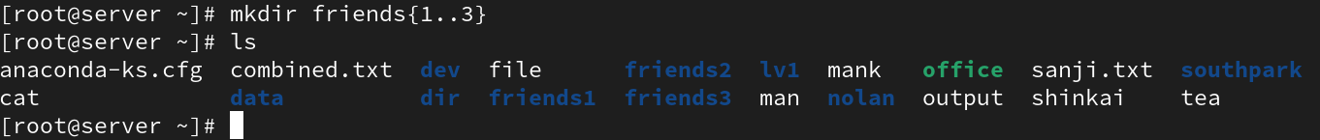

• How can you specify the full path for creating a directory in a specific location?

Use the full path. Example: `mkdir /home/user/newdir`

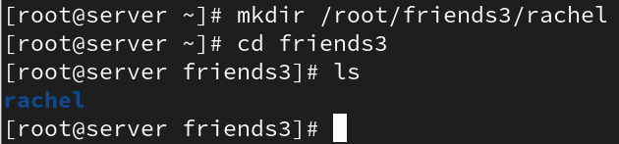

• What happens if you try to create a directory with a name that already exists in the current location?

The system shows an error: `mkdir: cannot create directory: File exists`.

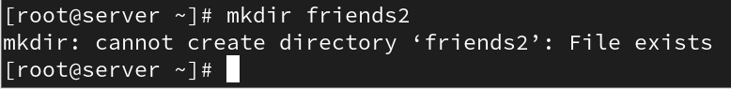

• Is it possible to create a directory with a space in its name? If yes, how?

No it will create to directories



• How can you verify that a directory has been successfully created?

Use `ls` or `ls -l` to check if it exists.

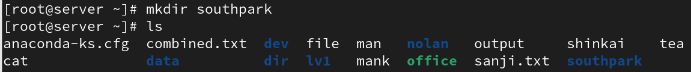

• Is there a way to create directories with specific permissions using the mkdir command?

Yes, use the `-m` option. Example: `mkdir -m 755 newdir`

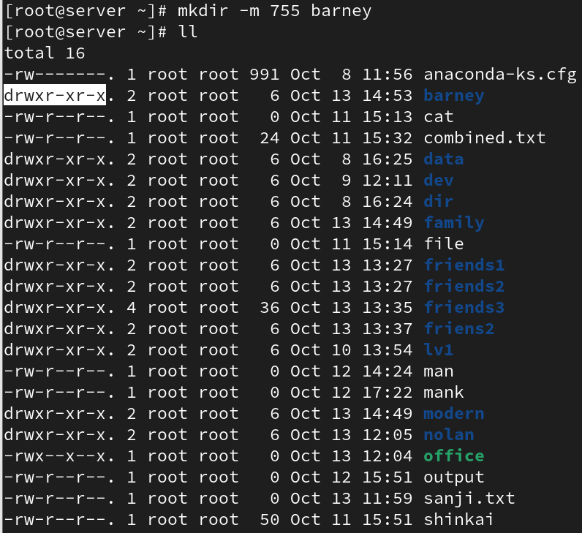

• How can you create nested directories (directories within directories) using the mkdir command?

Use the `-p` option. Example: `mkdir -p parent/child/grandchild`

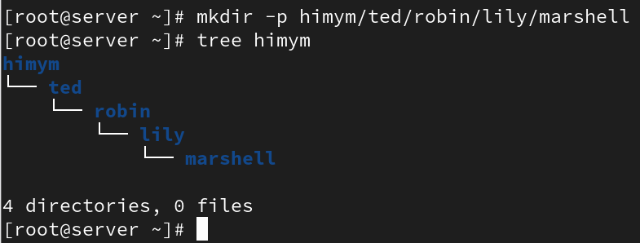

• Can you create a directory with a relative path instead of an absolute path? If yes, how?

Yes. Example: `mkdir ../newdir` creates it relative to the current directory.

L



### 5. Copy (cp) Command

* • How do I copy a file to a different directory using the cp command?

Example: `cp file1 /home/user/Documents/`

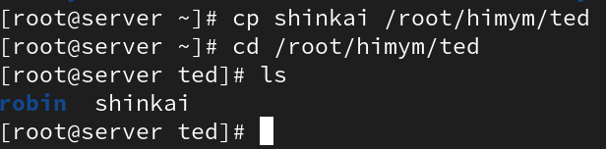

* • Can I preserve the original file permissions when copying with cp?

Yes, use `cp -p file1 /path/`

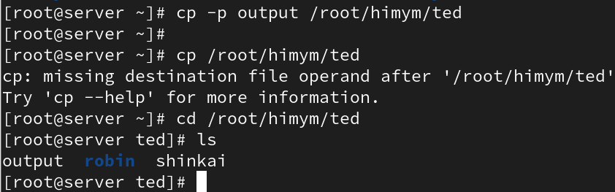

* • How can I copy multiple files at once using the cp command?

Example: `cp file1 file2 file3 /destination/`

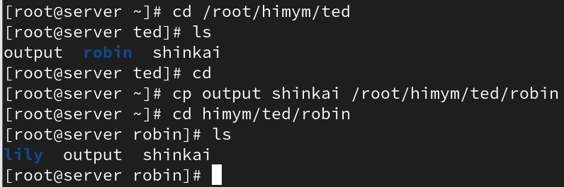

• Is it possible to overwrite an existing file when copying with cp?

Yes, by default cp overwrites files. Use `-i` to prompt before overwrite.



• How can I copy a directory and its contents using cp?

Use the `-r` option. Example: `cp -r dir1 /backup/`

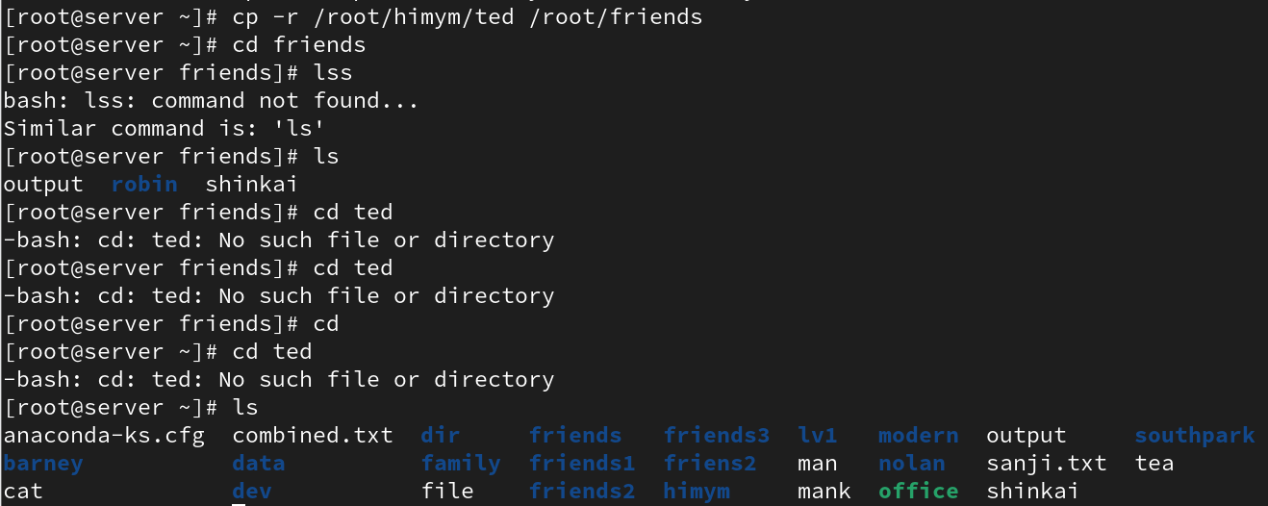

### Move (mv) Command

• How do I move a file to a different directory using the mv command?

Example: `mv file1 /home/user/Documents/`

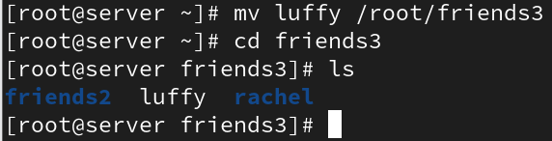

• Can I rename a file while moving it with the mv command?

Yes. Example: `mv oldname.txt newname.txt`

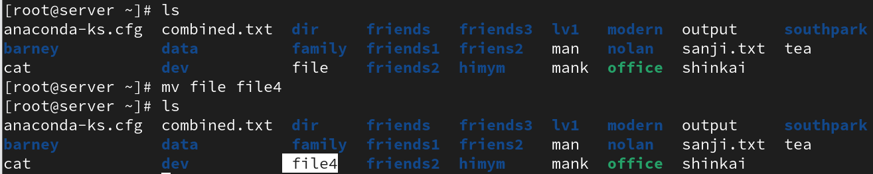

• What happens if I move a file to a directory where a file with the same name already exists?

It overwrites the existing file unless `-i` is used.

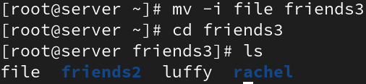

• How can I move multiple files at once using the mv command?

Example: `mv file1 file2 /destination/`



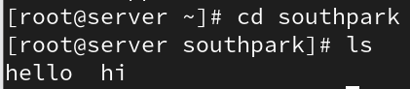

• Is it possible to move a directory and its contents using mv?

Yes. Example: `mv dir1 /newpath/`

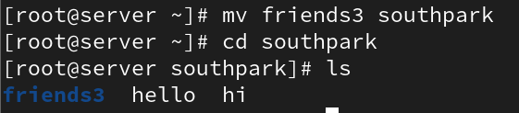

### Remove (rm) Command

• How do I remove a file using the rm command?

Example: `rm file1`

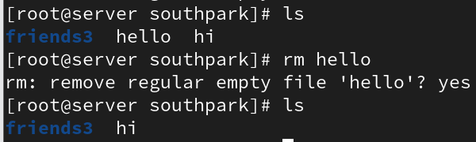

• Can I remove multiple files at once using the rm command?

Yes. Example: `rm file1 file2 file3`

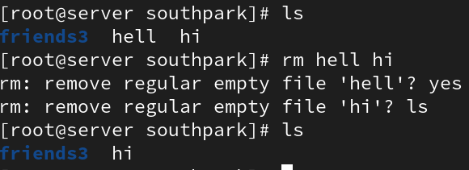

• How can I remove a directory and its contents using the rm command?

Use `rm -r directory_name`

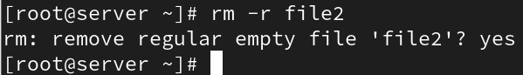

• What happens if I try to remove a file that is write-protected or has special permissions?

You cant it will show permission denied

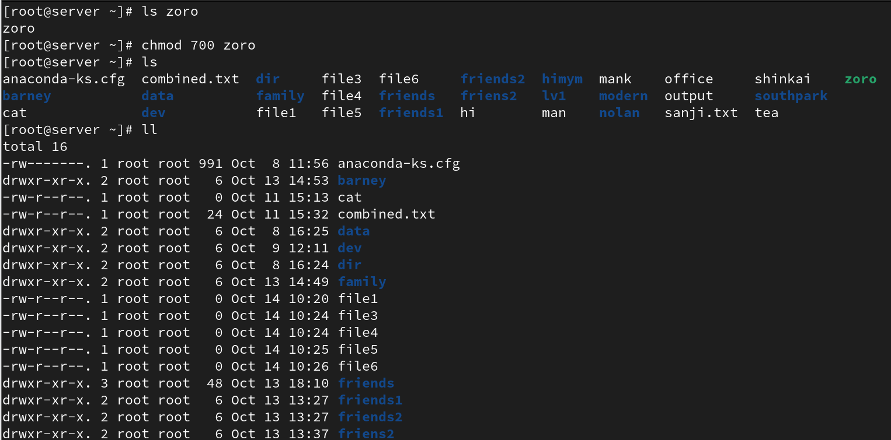

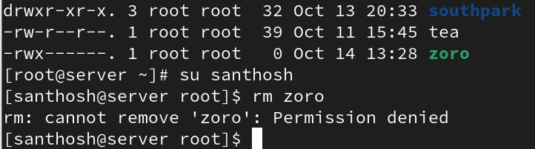

• Is there a way to force the removal of files or directories using rm?

Yes, use `rm -rf directory_name`

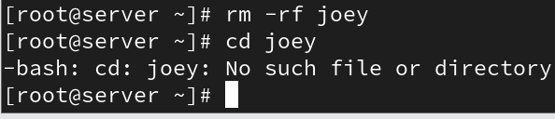

# 6. File & Directory Permissions

* What are the three basic permissions for a file in Linux?

Read (r), Write (w), and Execute (x).



* How are file permissions represented in the output of the ls -l command?

As a 10-character string (e.g., -rw-r--r--).



* What does the 'r' permission indicate for a file? What about 'w' and 'x'?

'r' = read, 'w' = write, 'x' = execute.

* How can you change the permissions of a file using the chmod command?

Use chmod followed by permission and filename (e.g., chmod 755 file).

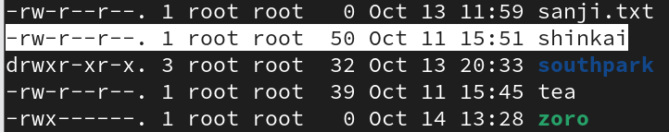

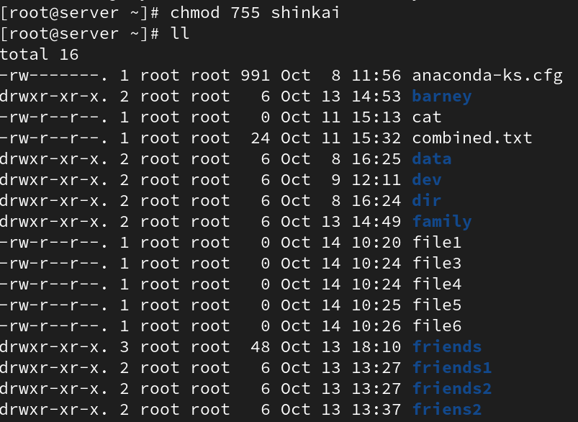

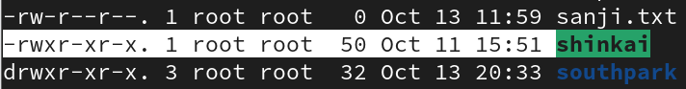

* What does the numeric representation 644 mean in terms of file permissions?

Owner: read/write, Group: read, Others: read.

* How can you change the permissions of a directory in Linux?

Use chmod with directory name (e.g., chmod 755 dir).



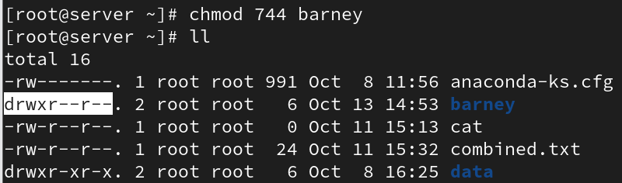

* What does the 'x' permission mean for a directory?

It allows entering or accessing files inside the directory.

* How do you recursively change the permissions of all files and directories within a directory?

Use chmod -R option (e.g., chmod -R 755 dir).

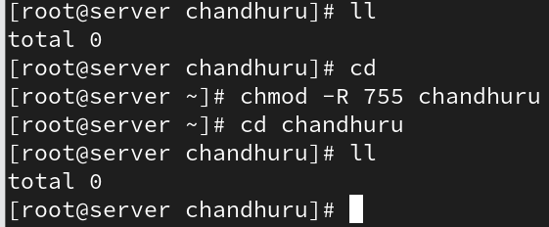

* What is the difference between the chmod command and the chown command?

chmod changes permissions; chown changes ownership.

* How can you check the permissions of a directory using the ls command?

Use ls -ld directory_name.

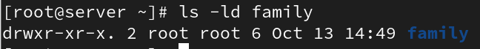

# 7. Vi Editor in Linux

* What is the purpose of the Vi editor in Linux?

To create and edit text files.

* What is the command to open a file in Vi for editing?

vi filename

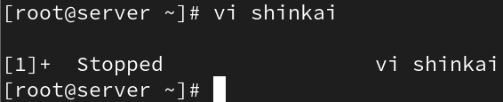

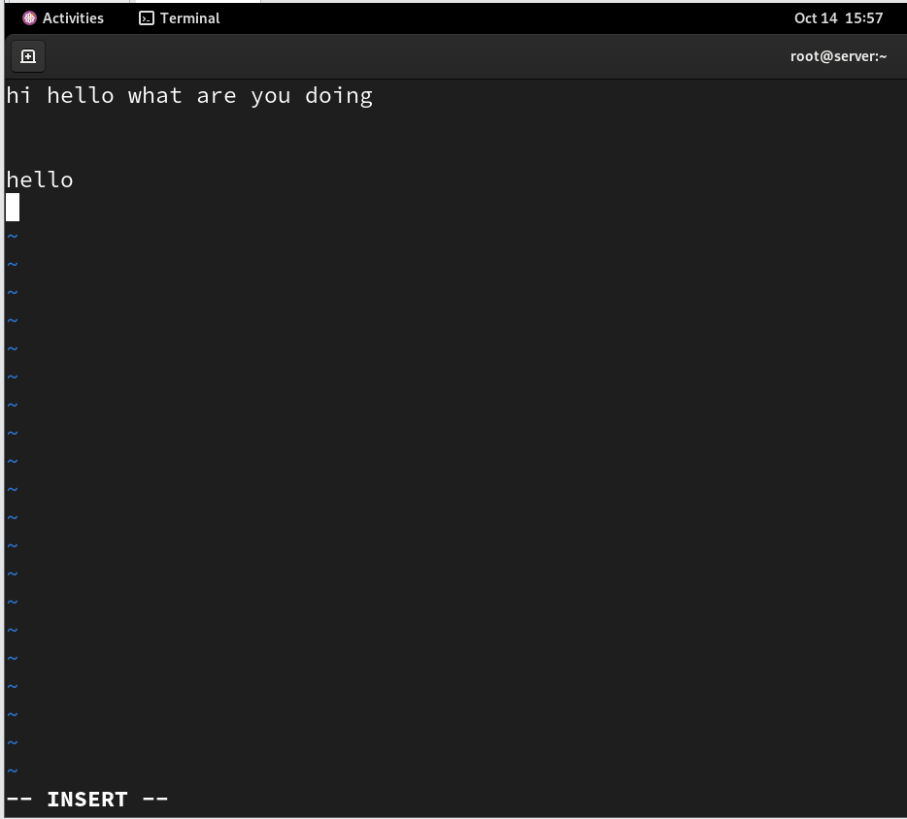

* How do you switch to insert mode in Vi to start adding or modifying text?

Press 'i' in normal mode.

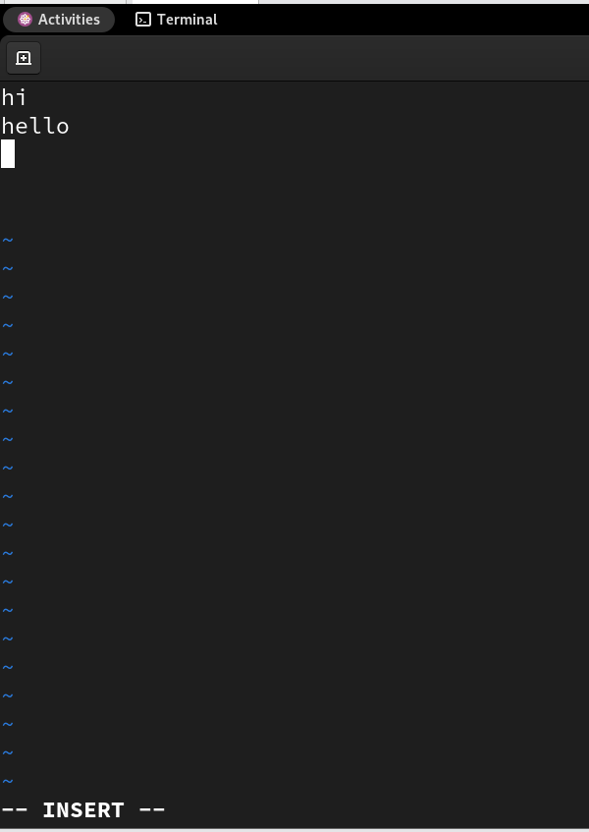

* How do you save changes and exit Vi?

Press :wq and Enter.



* What is the command to exit Vi without saving changes?

Press :q! and Enter.

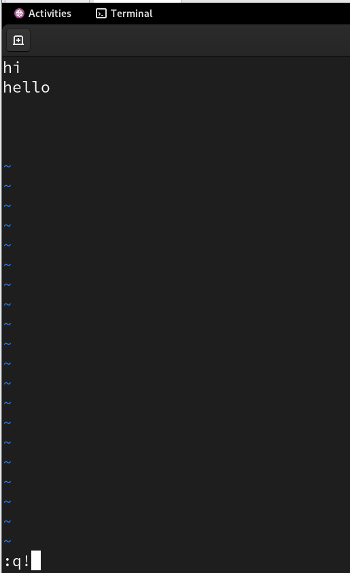

* How can you move the cursor to the beginning and end of a line in Vi?

Use 0 for beginning, $ for end.

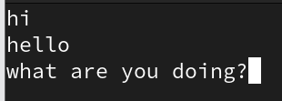

* What is the command to search for a specific word or pattern in Vi?

Use /word and press Enter.

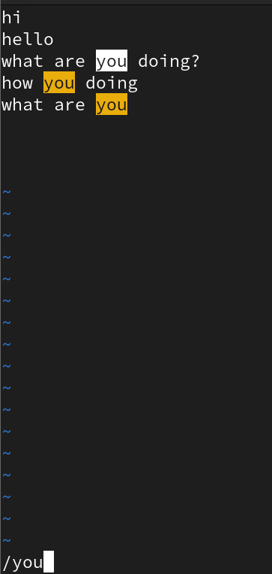

* How can you delete a character or a line in Vi?

x deletes a char; dd deletes a line.

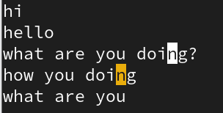

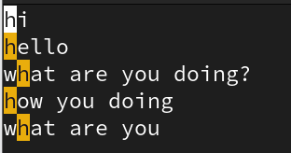

* How do you copy and paste text in Vi?

yy copies a line; p pastes it.

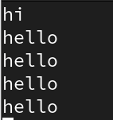

* What are some basic navigation commands in Vi to move between sections?

h, j, k, l for left, down, up, right; G to end, gg to top.

* How do you search for a specific word or phrase in Vi?

Use / followed by the word.

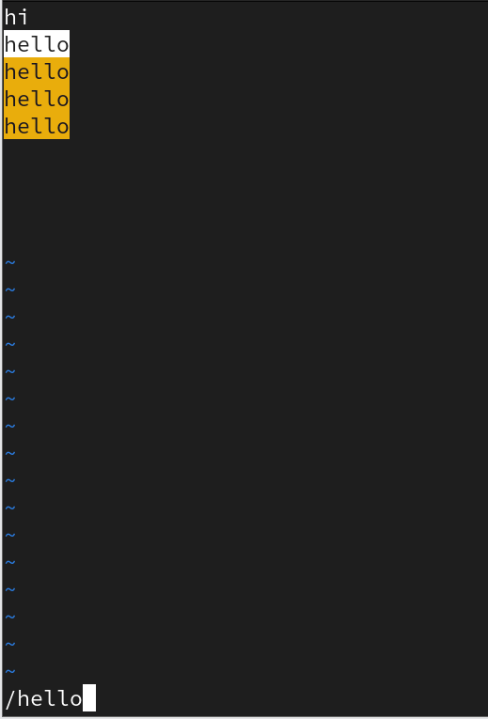

* What is the difference between the :w and :wq commands in Vi?

:w saves only; :wq saves and quits.

* How do you delete a single character in normal mode?

Use x key.

# 8. Special Permissions in Linux

* What are the three special permissions in Linux?

setuid, setgid, and sticky bit.

* What is the purpose of the setuid permission?

Allows users to run an executable with the file owner's privileges.

* How is the setuid permission represented in the output of the ls -l command?

Shown as 's' in the user’s execute field (e.g., -rwsr-xr-x).



* What is the effect of the setuid permission on an executable file?

It runs with the owner's privileges instead of the user's.

* What is the purpose of the setgid permission?

Ensures files created in a directory inherit the group ownership.

* How is the setgid permission represented in the output of the ls -l command?

Shown as 's' in the group’s execute field (e.g., drwxr-sr-x).



* What is the effect of the setgid permission on a directory?

Files inherit the directory's group ownership.

* What is the purpose of the sticky bit permission?

Prevents users from deleting others' files in shared directories.

* How is the sticky bit permission represented in the output of the ls -l command?

Shown as 't' in the others’ execute field (e.g., drwxrwxrwt).

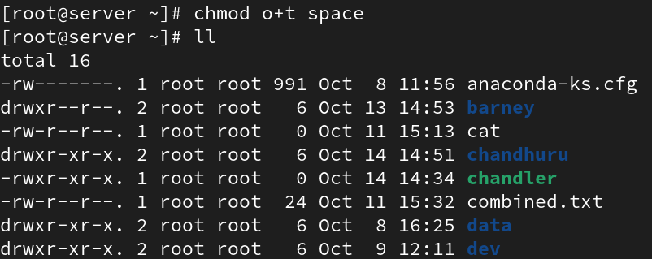

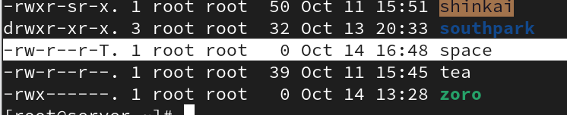

* What is the significance of the sticky bit on a directory?

Only the file owner or root can delete files inside it.

# 9. User and Group Administration in Linux

* What is the command to create a new user in Linux?

useradd username

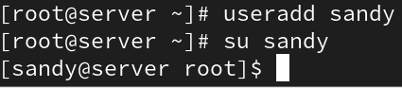

* How can you specify a user's home directory during user creation?

useradd -d /home/dirname username



* How do you assign a password to a user account in Linux?

passwd username

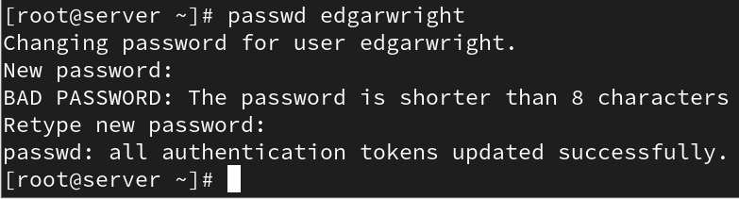

* What command is used to delete a user from the system?

userdel username



* How can you add an existing user to a specific group?

usermod -aG groupname username



* What command is used to create a new group in Linux?

groupadd groupname

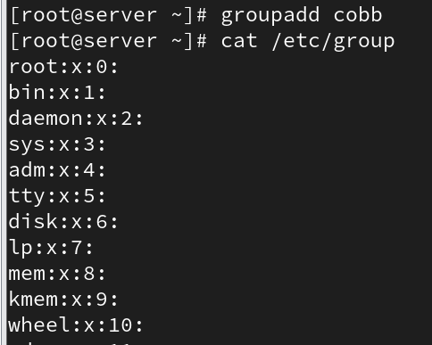

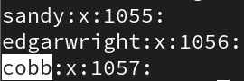

* How do you add a user to a newly created group?

usermod -aG groupname username



* What is the purpose of the chgrp command?

Changes the group ownership of a file.

* How can you list all the users on a Linux system?

View /etc/passwd file or use getent passwd.

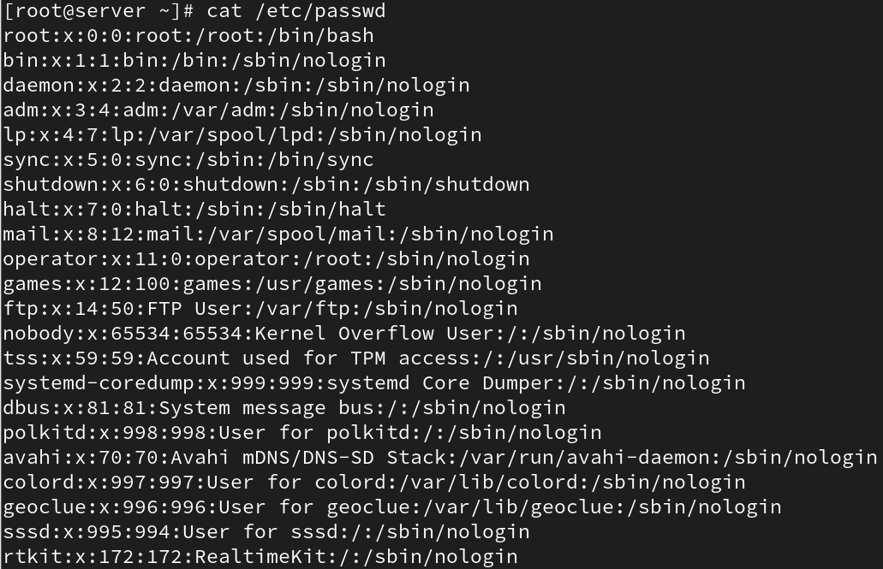

* What command can you use to modify a user’s account settings?

usermod command.

* How can you assign a user to a specific group during user creation?

useradd -G groupname username

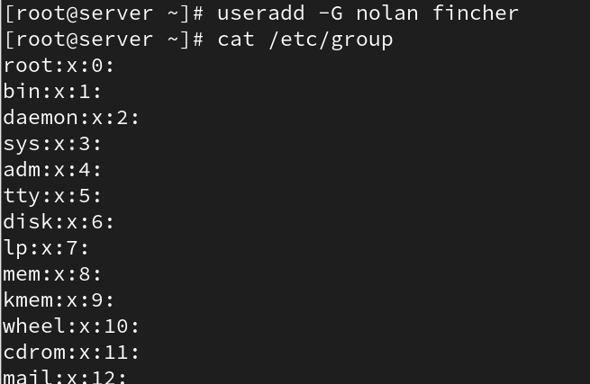

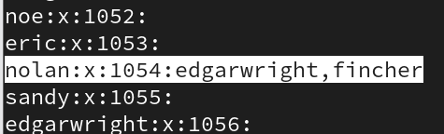

* What is the purpose of the usermod command?

Modifies user account details.

* How do you change a user's password in Linux?

passwd username

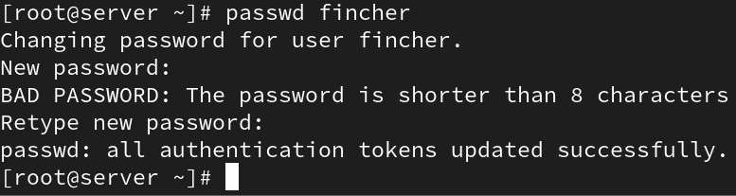

* How do you lock or unlock a user account using the passwd command?

passwd -l username (lock), passwd -u username (unlock).

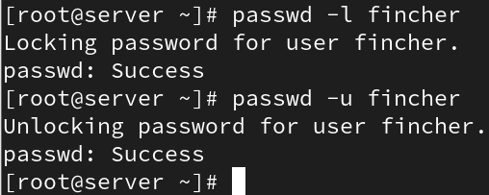

* What is the purpose of the groupadd command?

Creates a new group.

* How can you remove a user from a group?

gpasswd -d username groupname.

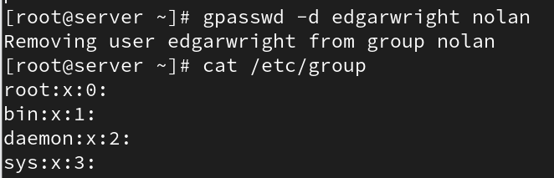

* What command is used to delete a user account in Linux?

userdel username.

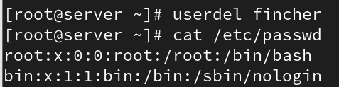

* How do you display details of a specific user?

Use id or finger username.

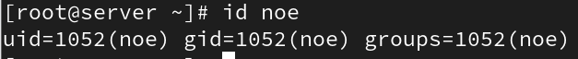

* What is the difference between useradd and adduser commands?

useradd is low-level; adduser is a friendly interactive script.

* What is the purpose of the /etc/passwd file in Linux?

Stores user account information.

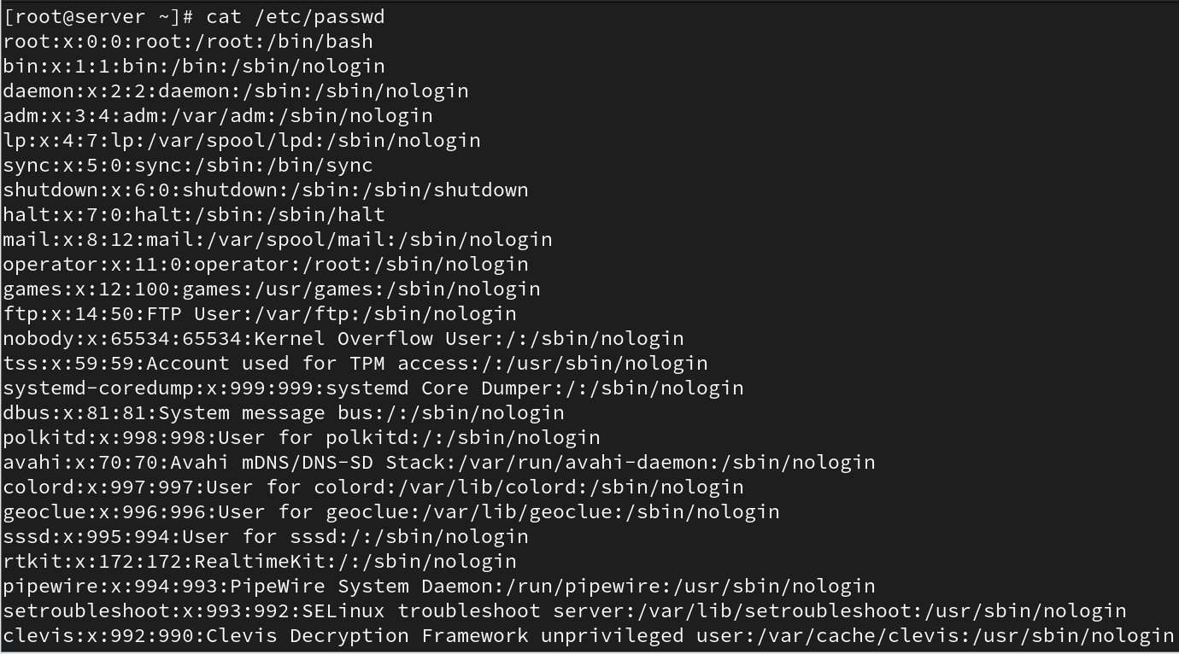

* What is the purpose of the /etc/shadow file?

Stores encrypted passwords and password policies.

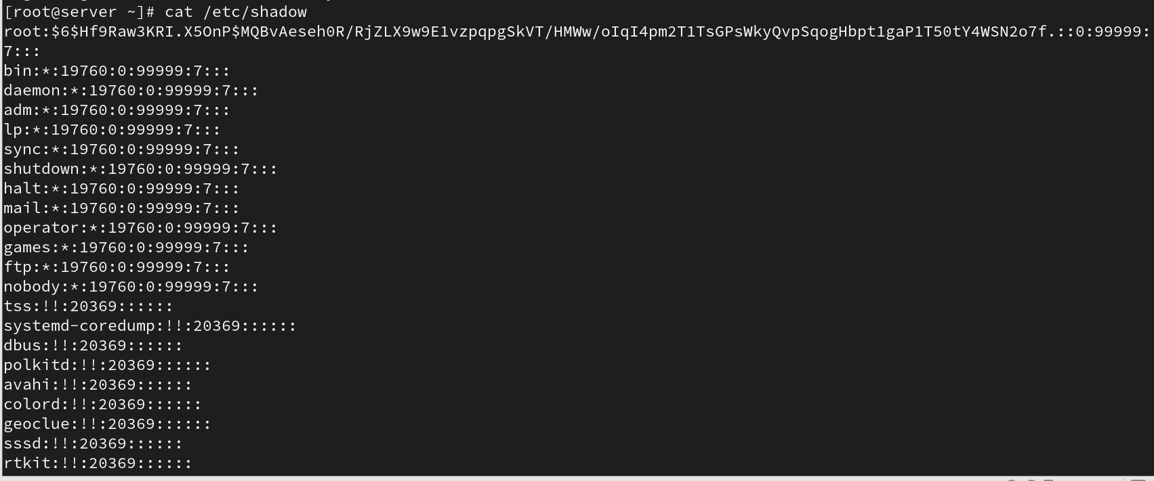

* What is the purpose of the /etc/gshadow file?

Stores group password and admin information.

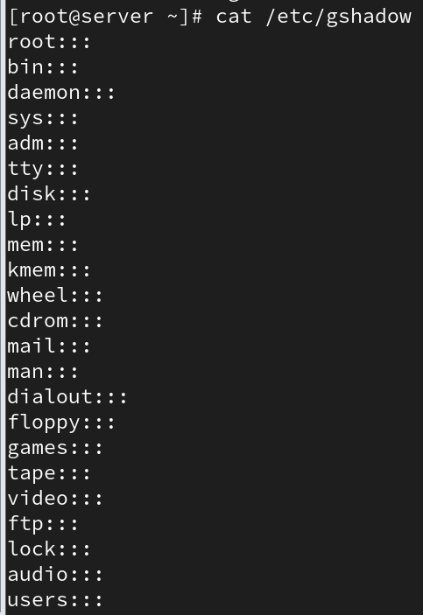

* What is the purpose of the /etc/group file?

Defines groups and their members.

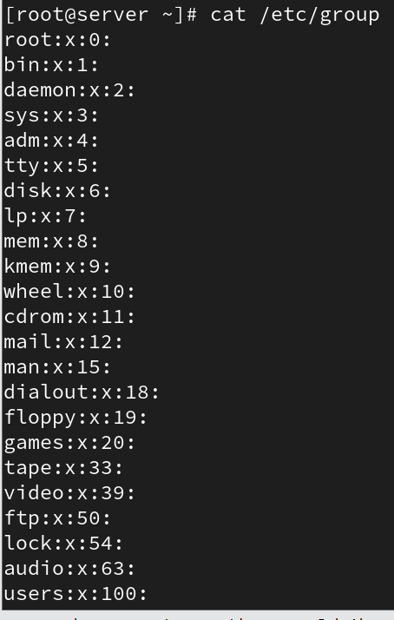

* How can you view the contents of these files?

Use cat, less, or more commands.



# 10. Processes in Linux

* What is a process in Linux?

An instance of a running program.

* How can you view the currently running processes?

Use ps, top, or htop commands.

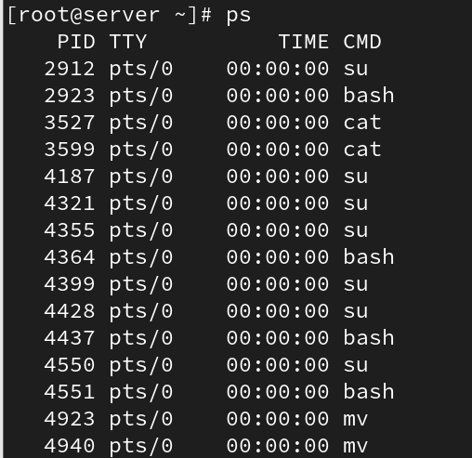



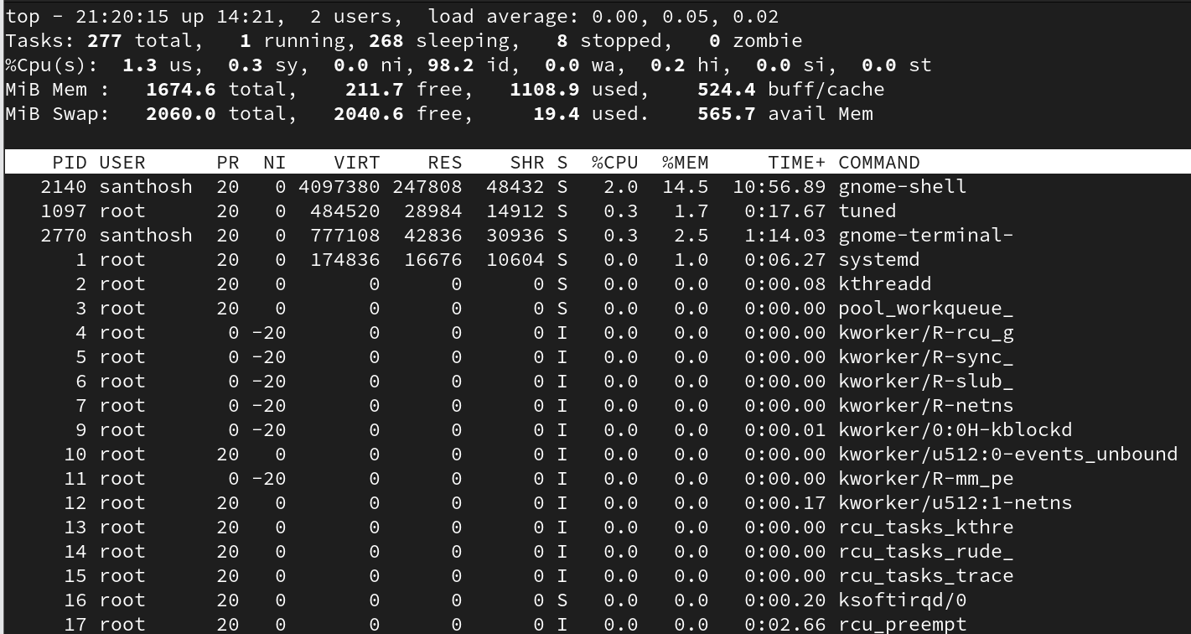

* What command is used to start a new process?

Run the program or script name directly.



* How can you identify the process ID (PID)?

Use ps or pgrep command.

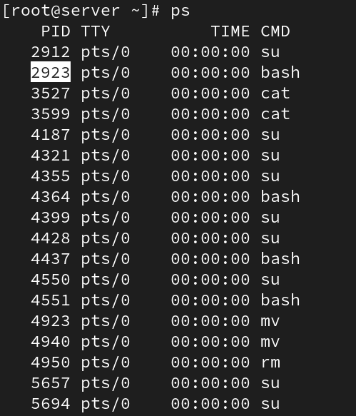



* What is the purpose of the ps command?

Displays running processes and their status.

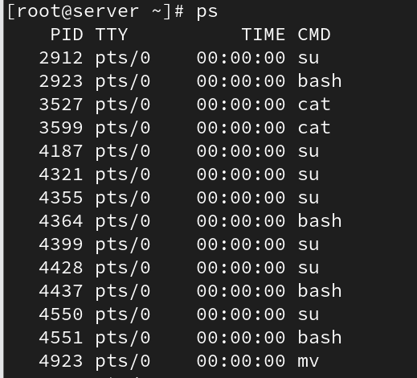



* How can you terminate a process?

Use kill or killall command.



* What is the difference between a foreground and background process?

Foreground runs interactively; background runs detached.

* How do you start a process in the background?

Append '&' at the end of the command.



* How can you check the status of a process?

Use ps or top command.

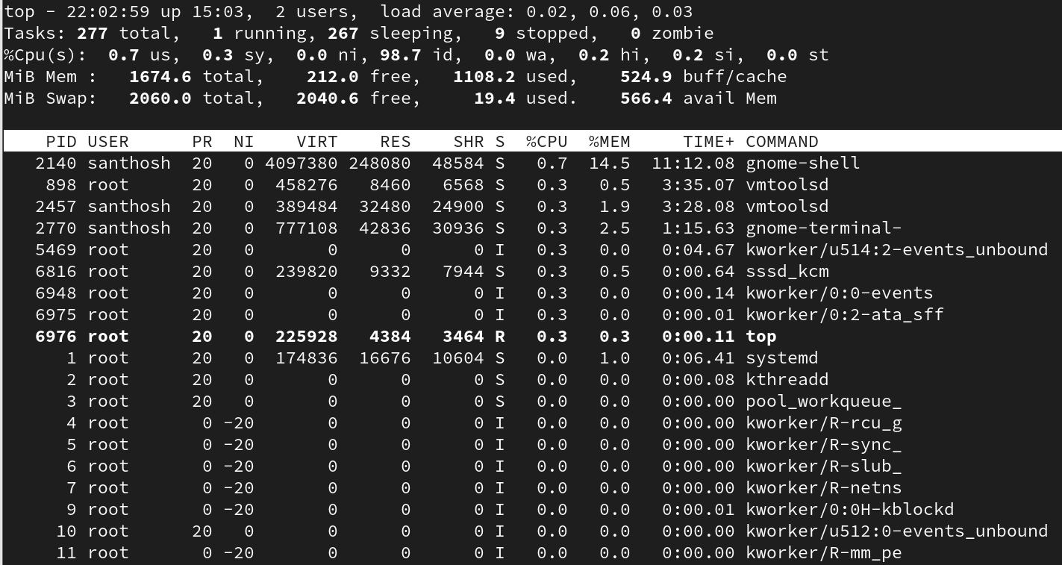

* What is a parent process and a child process?

Parent spawns child processes.

* How can you change the priority of a process?

Use nice or renice command.



* What is the purpose of the top command?

Monitors real-time system processes and resource usage.

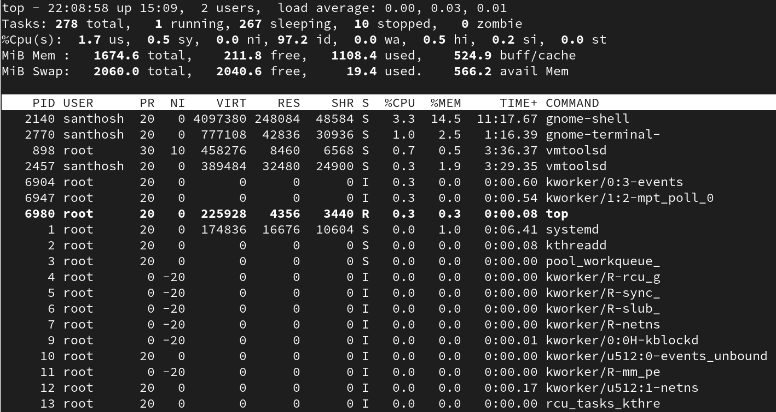

* How can you monitor resource usage of a process?

Use top, or ps aux.

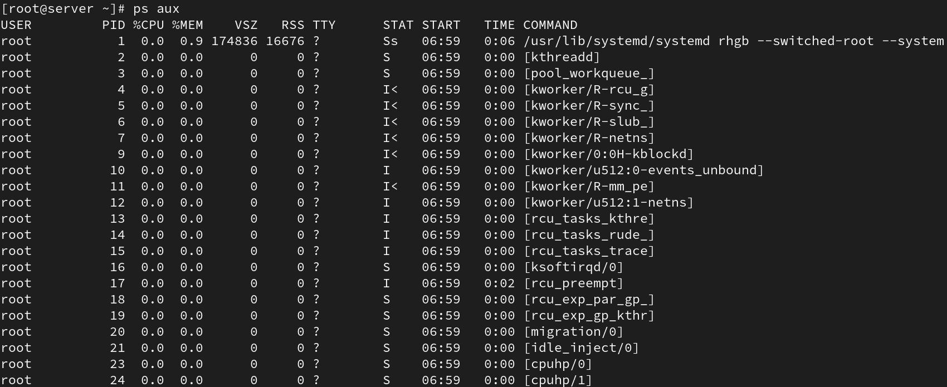

* What are the common process states?

Running, Sleeping, Zombie, Stopped.

* How can you send signals to a process?

Use kill -SIGNAL PID (e.g., kill -9 PID).

* How do I run the top command?

Type top in terminal.

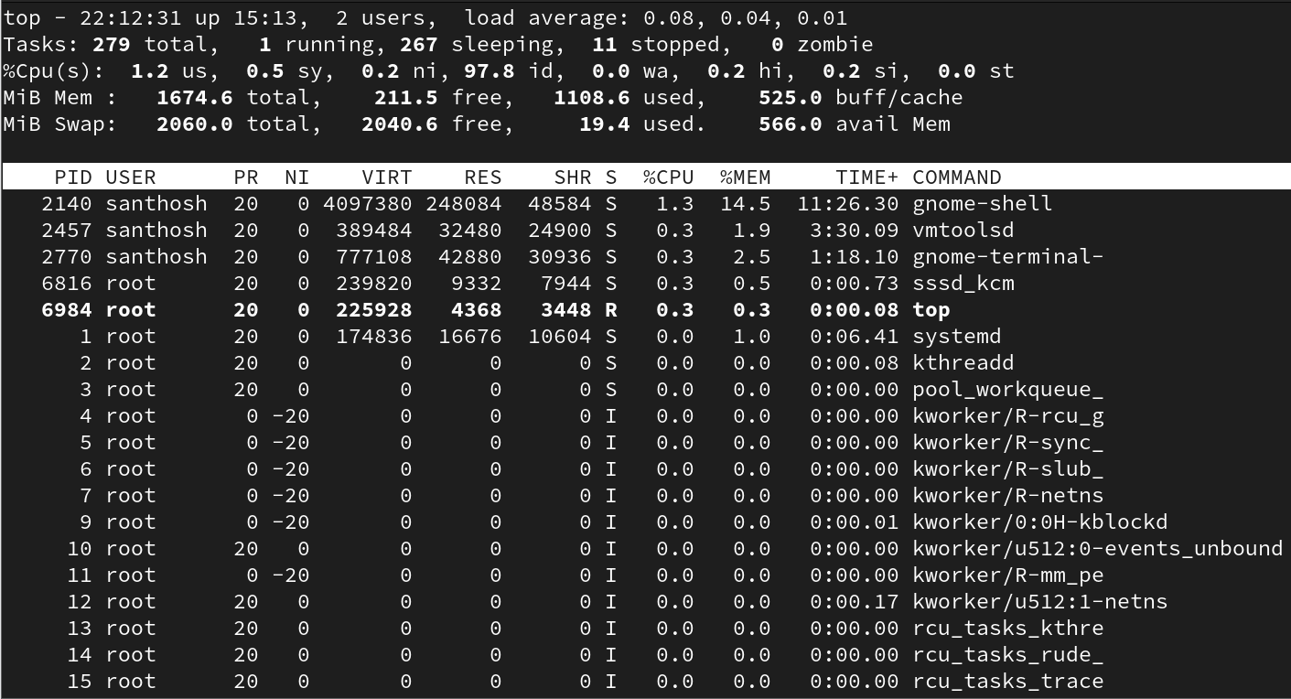

* What information does top display?

CPU, memory, PID, user, and command info.



* How do I interpret CPU usage in top?

Shows CPU usage percentage for each process.

* How can I sort processes in top?

Press 'P' for CPU, 'M' for memory.

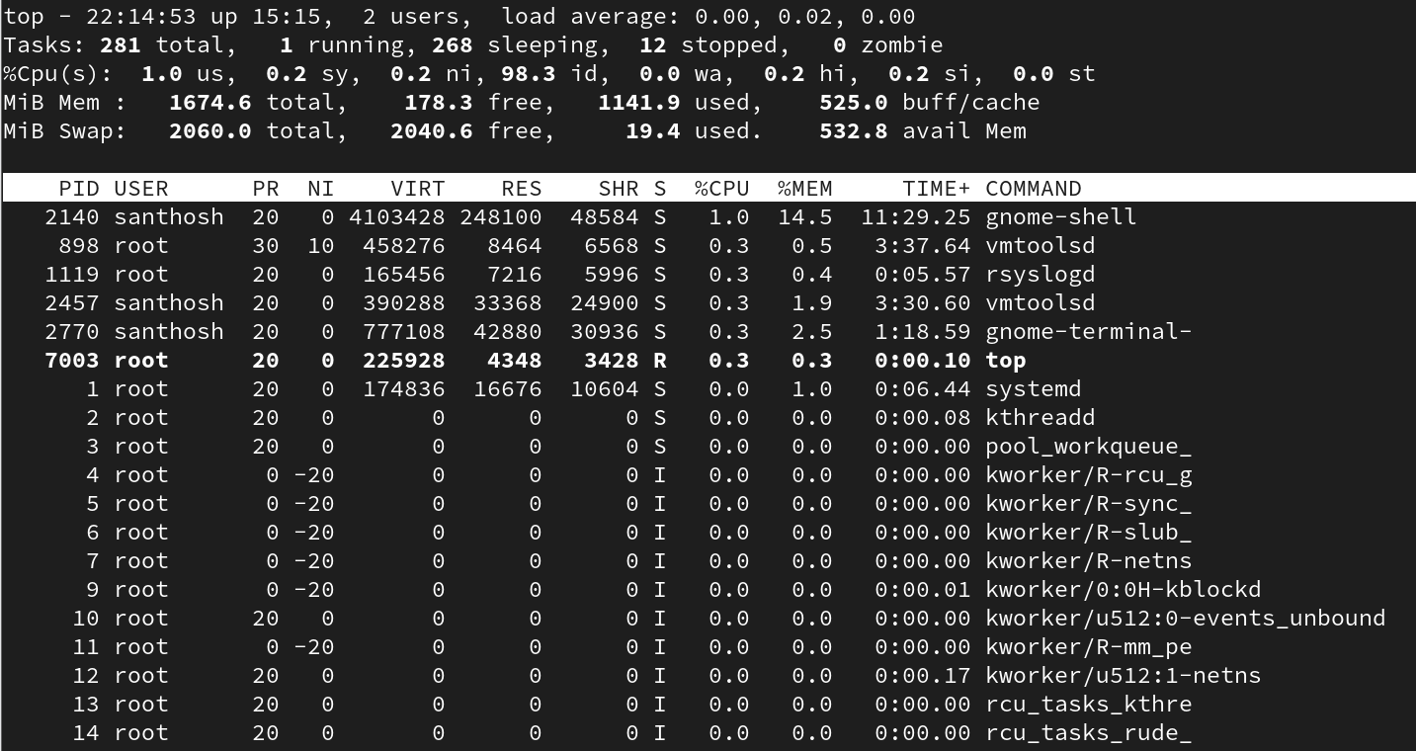

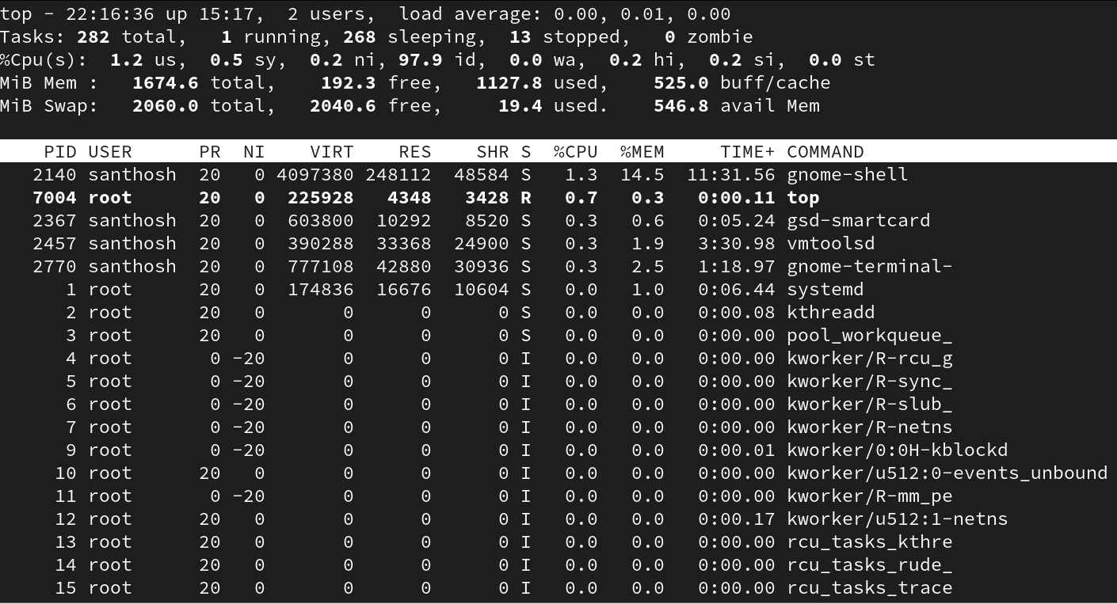

* Can I change update frequency in top?

Yes, press 'd' and set the delay time.

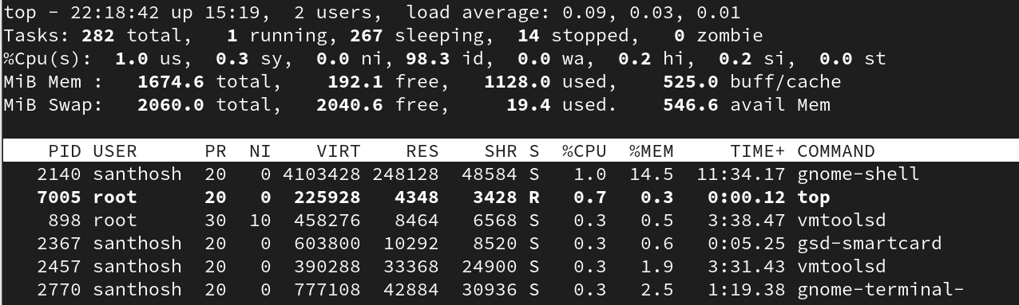

* How can I view processes of a specific user?

Use top -u username.



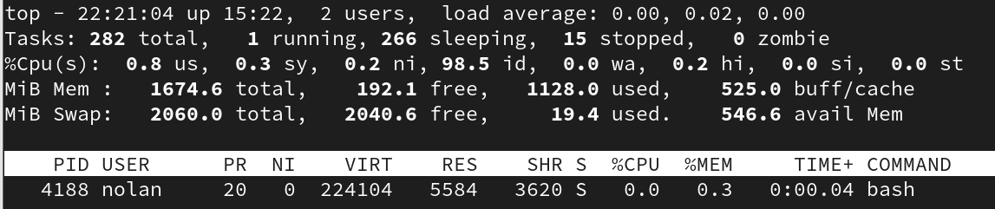

* Can top show full command line for each process?

Yes, press 'c' key.

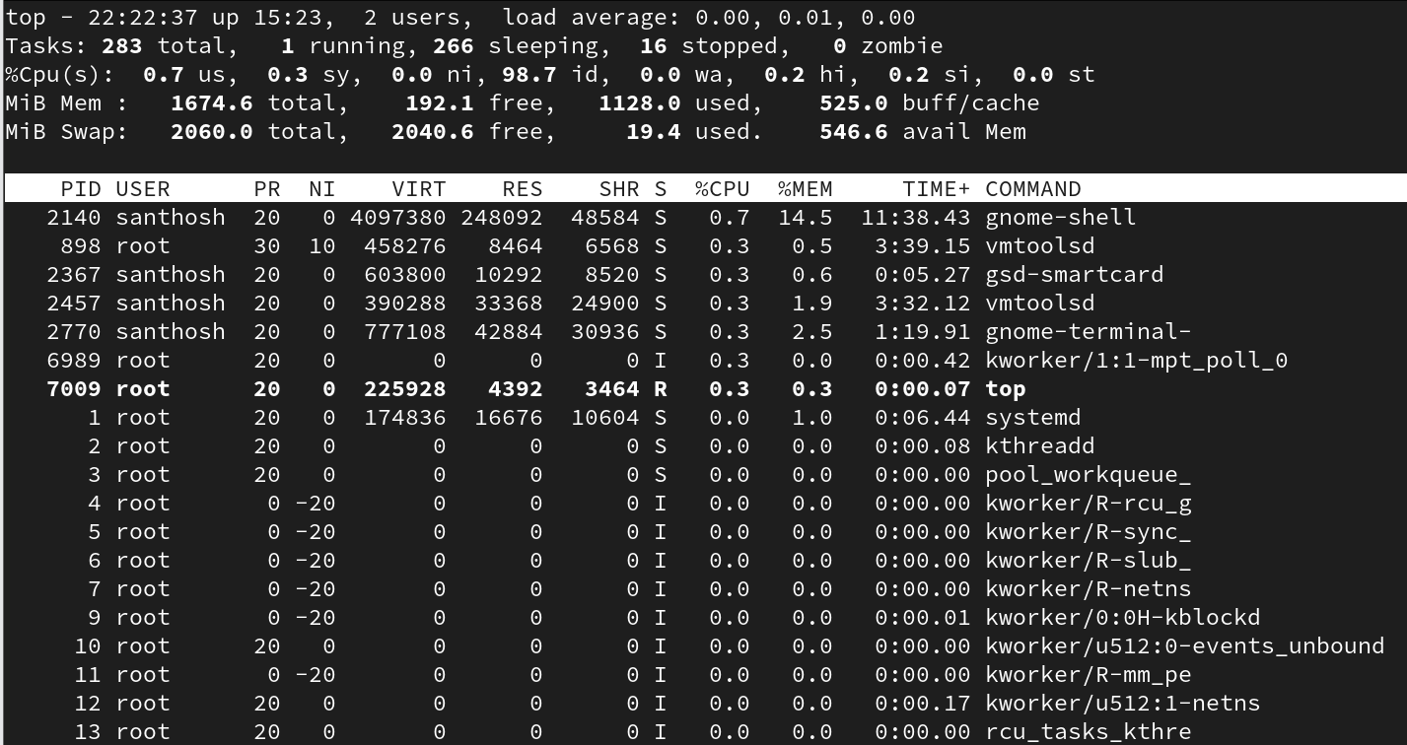

* How do I kill a process directly from top?

Press 'k' then enter the PID.

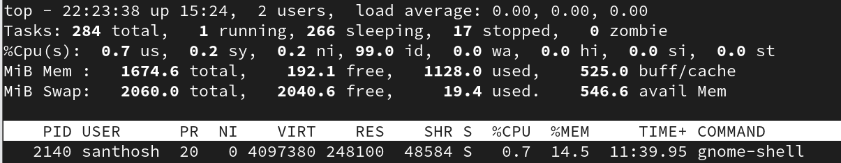

* Can top show overall system summary?

Yes, at the top section of the display.

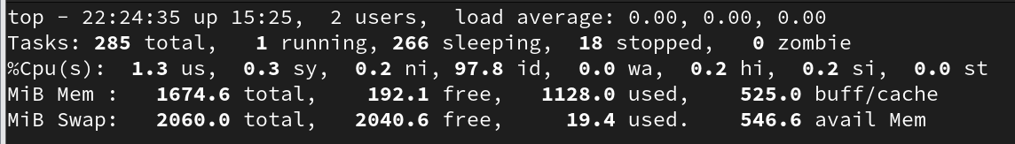

* How can I save top output to a file?

Use top -b -n 1 > file.txt.

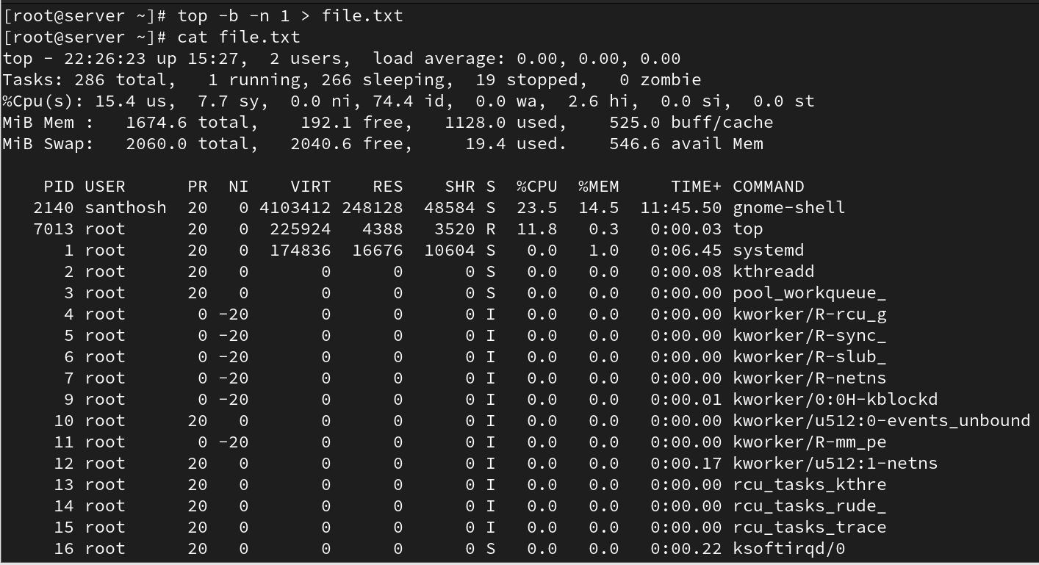

## 11. Services in Linux

* What is a service in the context of Linux?

A service is a background process that performs specific system functions, often managed by systemd.

* How can you check the status of a service in Linux?

Use 'systemctl status service_name'.

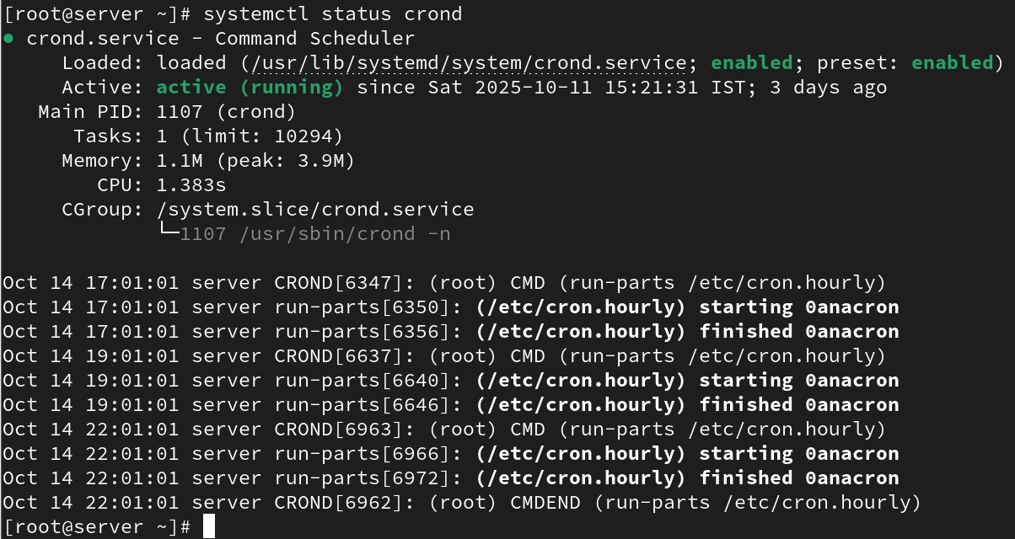

* What command is used to start a service in Linux?

Use 'systemctl start service_name'.

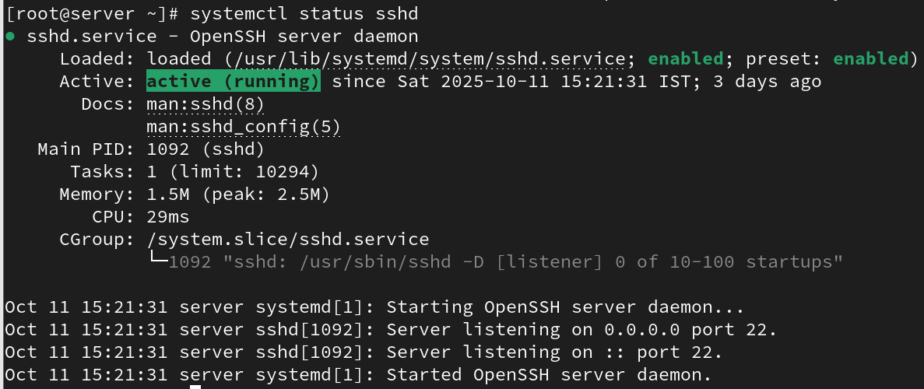

* How can you stop a running service in Linux?

Use 'systemctl stop service_name'.

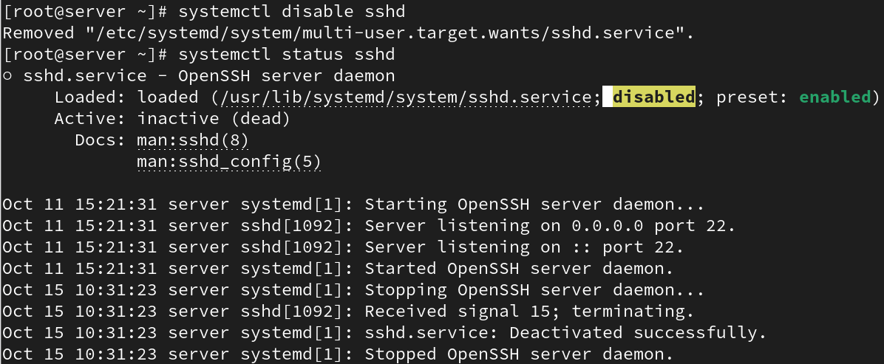

* What is the purpose of the systemctl command in Linux?

It controls and manages systemd services and units.

* How can you enable a service to start automatically at system boot in Linux?

Use 'systemctl enable service_name'.



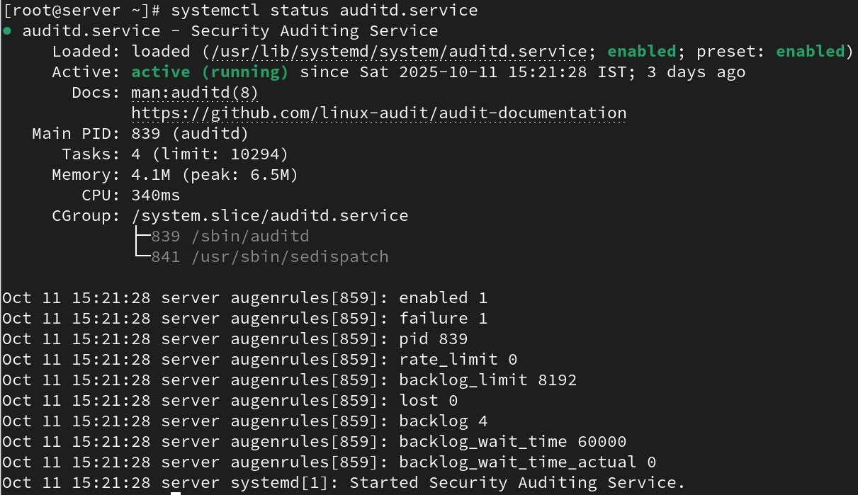

* What is the difference between a system service and a user service in Linux?

System services run for all users; user services run in a user's session.

* How can you restart a service in Linux?

Use 'systemctl restart service_name'.



* What command is used to view the list of available services in Linux?

Use 'systemctl list-units --type=service'.

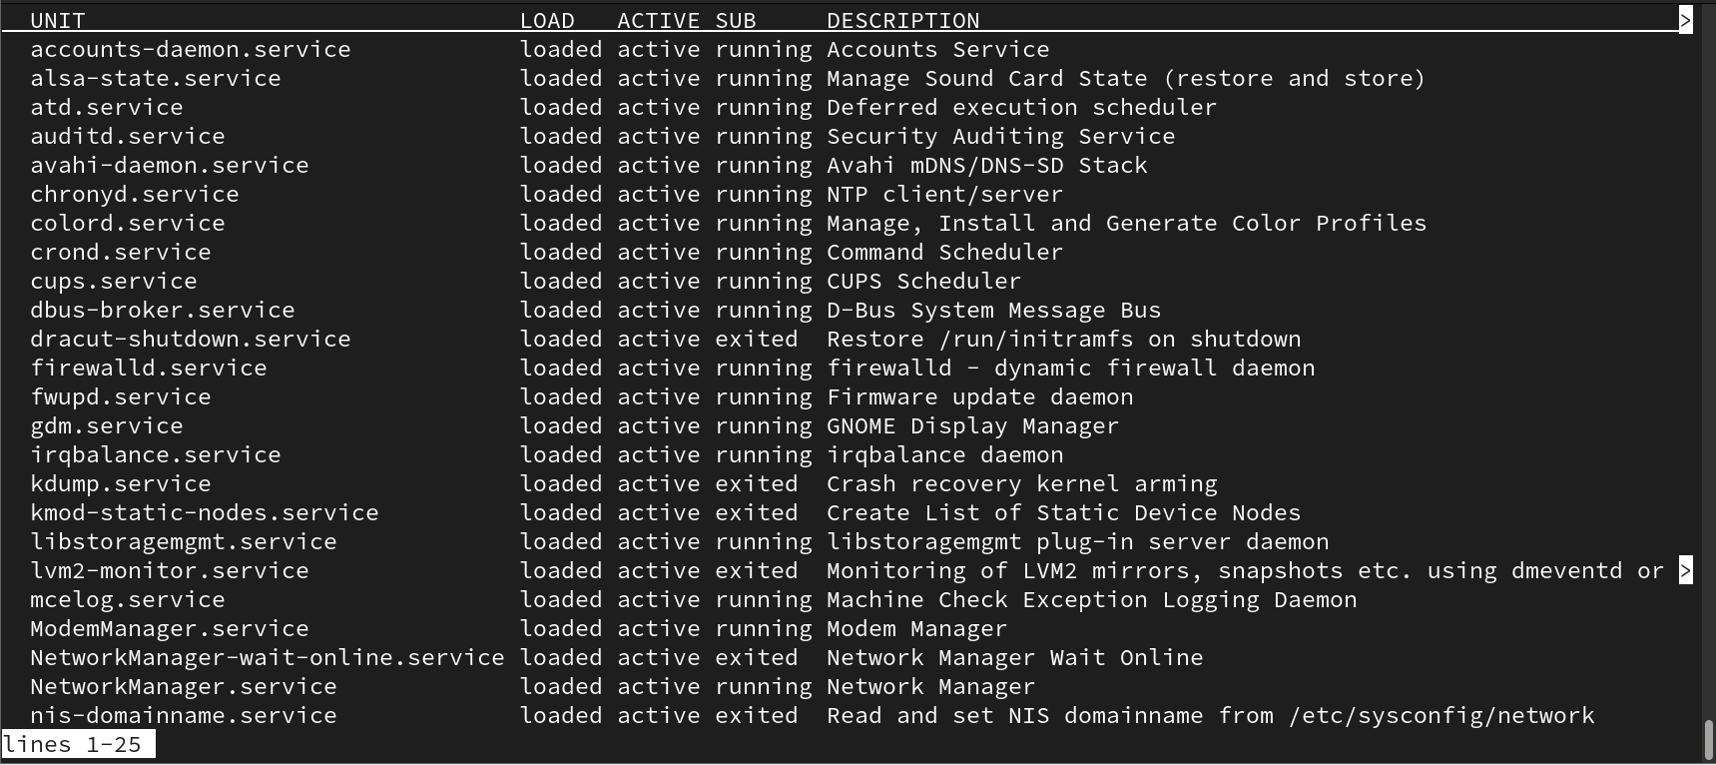

* How can you configure the behavior and settings of a service in Linux?

Edit its configuration file in /etc/systemd/system or use override files.



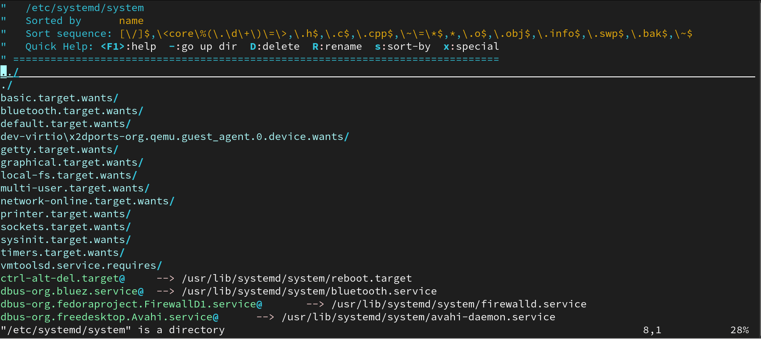

* What is the purpose of the /etc/init.d directory in Linux?

It contains legacy SysV-style service scripts.

* How can you create a custom service in Linux?

By creating a .service file in /etc/systemd/system and enabling it with systemctl.

* How can you check the logs and debug a service in Linux?

Use 'journalctl -u service_name'.

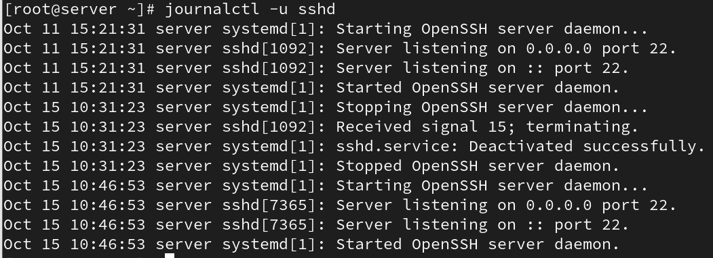

* What is the significance of service dependencies in Linux?

They define which services must start before or after another service.

## 12. Archiving and Transferring Files in Linux

* What command is used to create a tar archive of files and directories in Linux?

Use 'tar -cvf archive.tar files'.

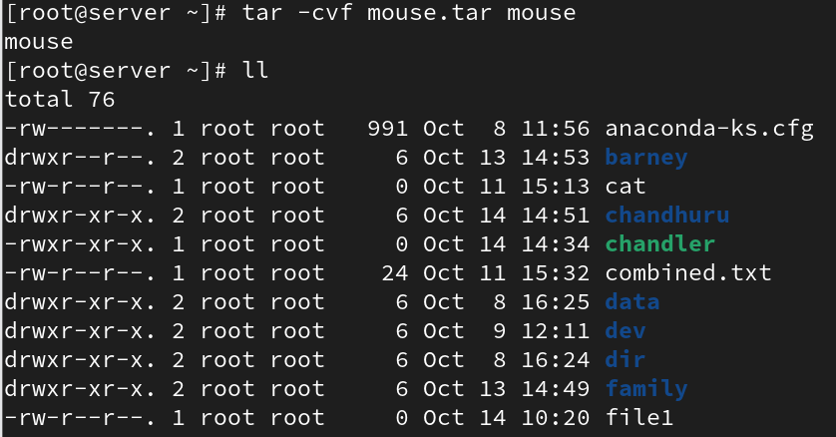

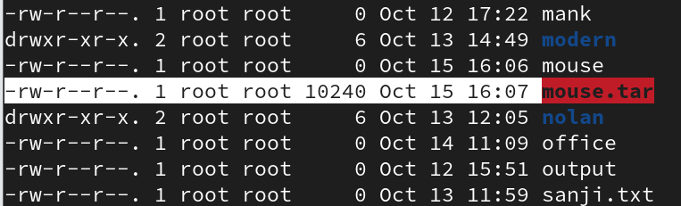

* How can you extract files from a tar archive in Linux?

Use 'tar -xvf archive.tar'.

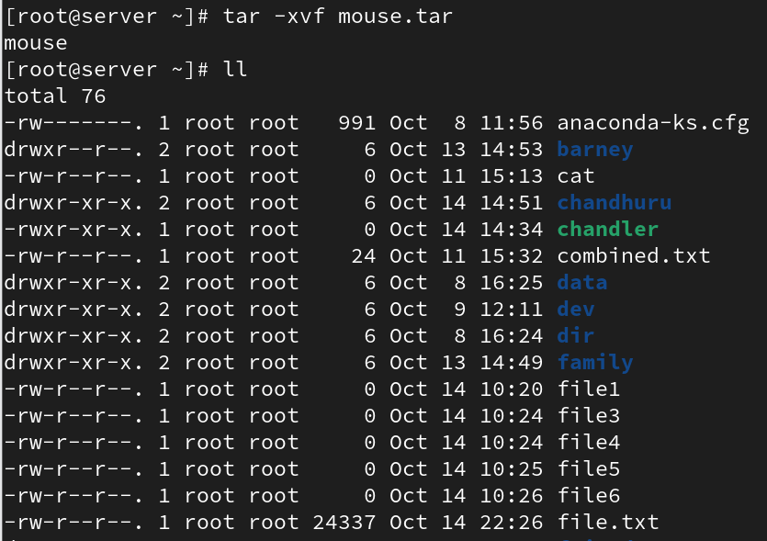

* What is the purpose of compression when creating an archive?

To reduce file size and save storage space.

* Which command is used to compress files into a gzip archive in Linux?

Use 'gzip filename'.

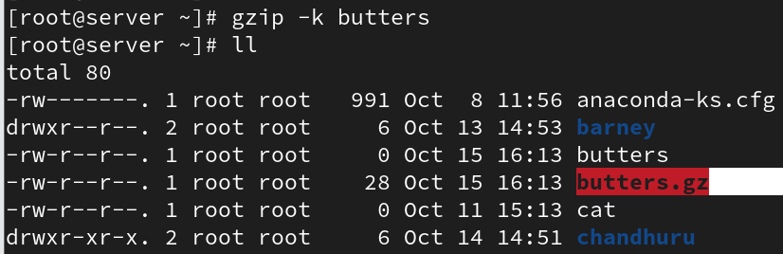

* How can you extract files from a gzip archive in Linux?

Use 'gunzip filename.gz'.

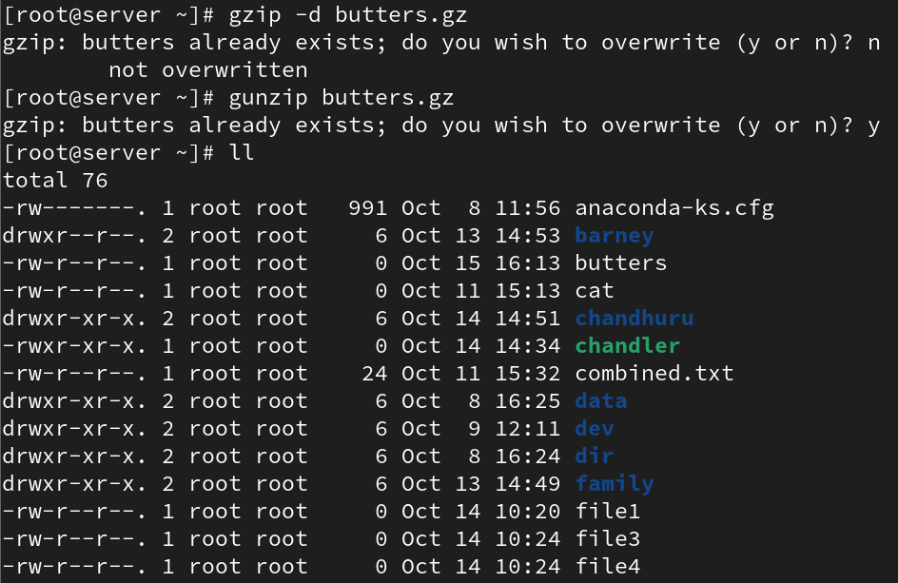

* How can you extract files from a bzip archive in Linux?

Use 'bunzip2 filename.bz2'.



* What is the difference between a tar archive and a compressed archive?

Tar groups files; compression reduces size.

* How can you create a zip archive of files and directories in Linux?

Use 'zip -r archive.zip files'.

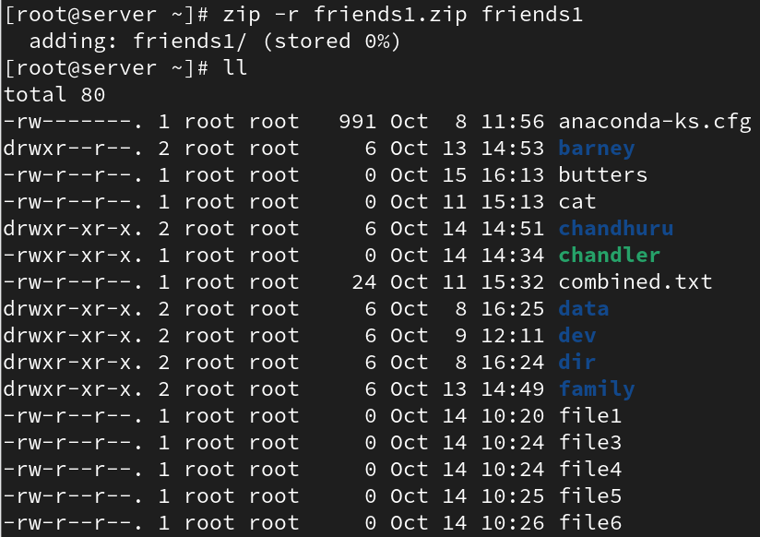

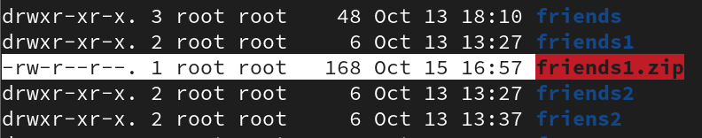

* What command is used to extract files from a zip archive in Linux?

Use 'unzip archive.zip'.

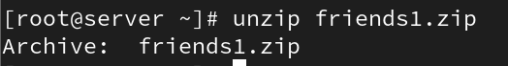

* How can you transfer files between Linux systems using the scp command?

Use 'scp file user@remote:/path'.

* What is the syntax for transferring a file using scp?

scp source_file user@host:/destination

* How can you transfer an entire directory using scp?

Use 'scp -r directory user@host:/destination'.

## 14. RPM Packages in Linux

* What is an RPM package in Linux?

A software package format used in Red Hat-based systems.

* How can you install an RPM package in Linux?

Use 'rpm -ivh package.rpm'.

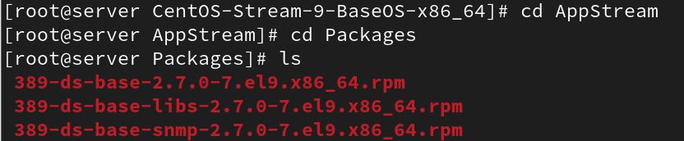

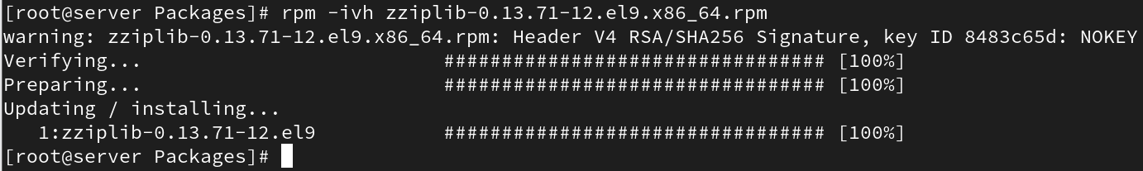

* What command is used to query information about an installed RPM package?

Use 'rpm -qi package_name'.

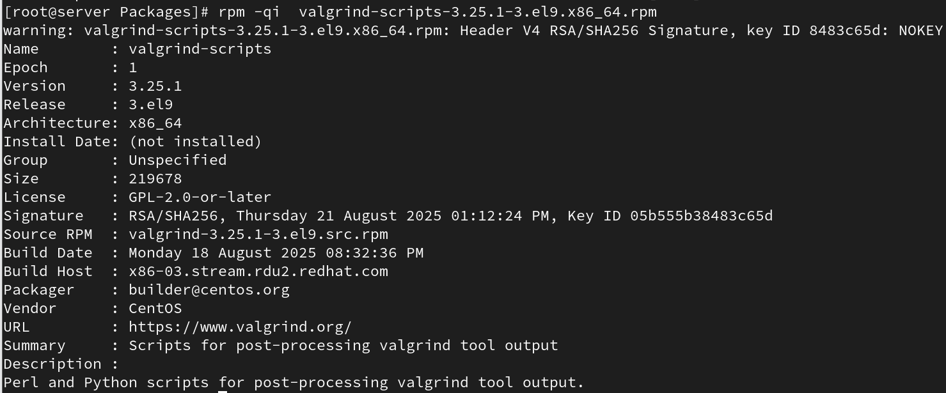

* How can you list all the files installed by an RPM package?

Use 'rpm -ql package_name'.

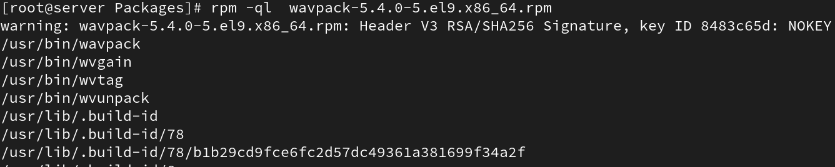

* What is the purpose of the RPM database in Linux?

It stores information about installed packages.

* What command is used to upgrade an installed RPM package to a newer version?

Use 'rpm -Uvh package.rpm'.

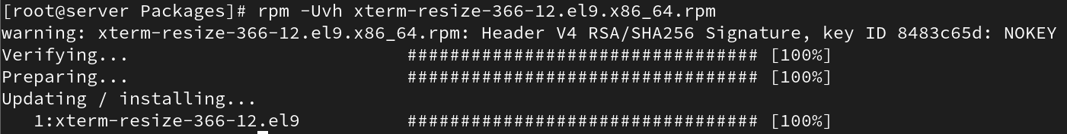

* How can you remove an installed RPM package from the system?

Use 'rpm -e package_name'.



* What is the purpose of dependency resolution in RPM packages?

It ensures all required packages are installed.

* How can you list the dependencies of an RPM package?

Use 'rpm -qpR package.rpm'.

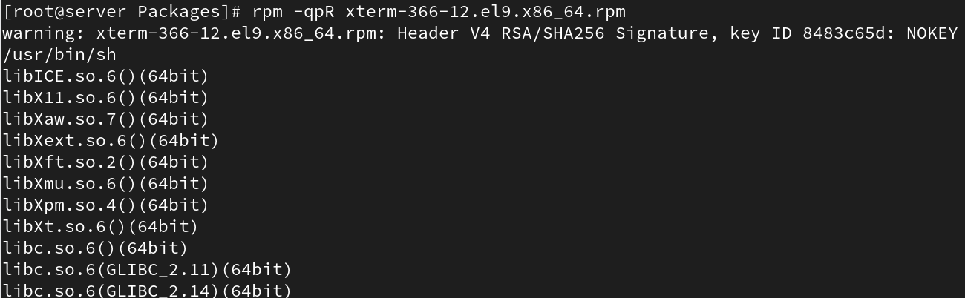

## 15. Yum in Linux

* What is Yum and what is its purpose in Linux?

Yum is a package manager for managing RPM packages with dependency resolution.

* How can you install a package using Yum in Linux?

Use 'yum install package_name'.

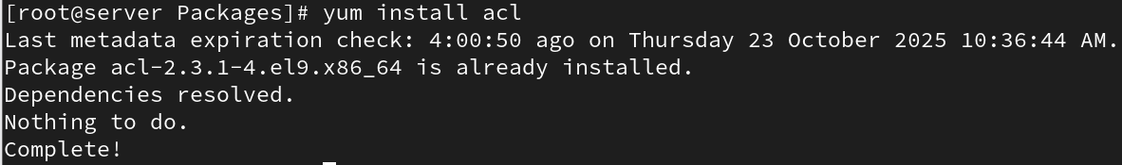

* What command is used to search for packages using Yum?

Use 'yum search keyword'.

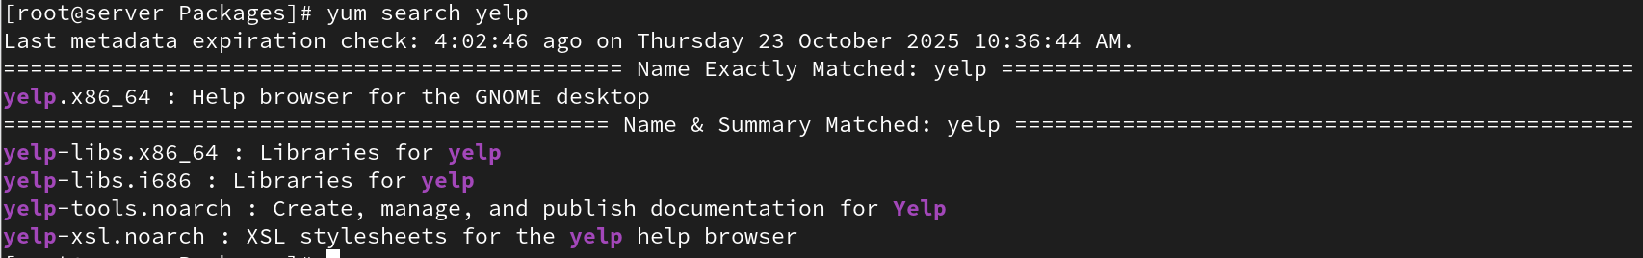

* How can you update all installed packages using Yum?

Use 'yum update'.

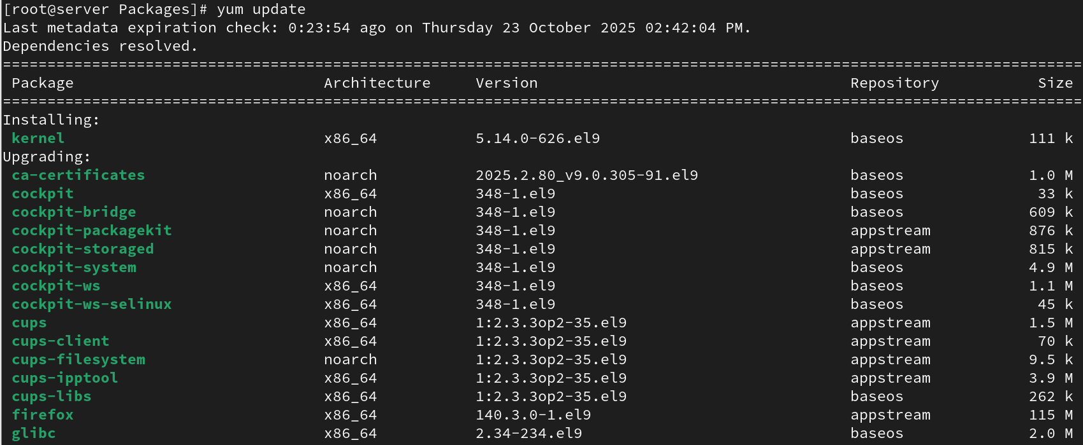



* What is the purpose of repositories in Yum?

They provide sources for software installation and updates.

* How can you enable or disable a repository in Yum?

Edit .repo files or use 'yum-config-manager'.

* What command is used to list the enabled repositories in Yum?

Use 'yum repolist enabled'.

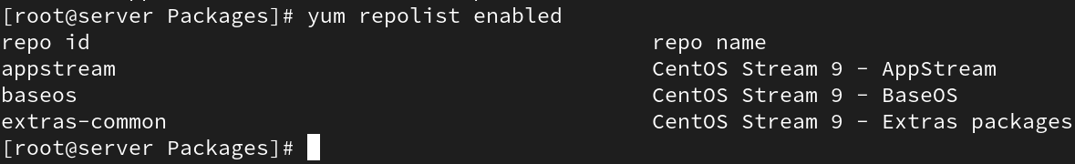

* How can you install a specific version of a package using Yum?

Use 'yum install package-name-version'.

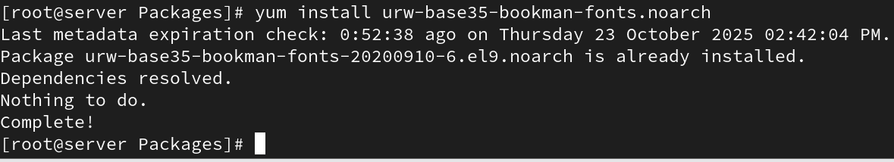

* What is the difference between Yum and RPM?

Yum resolves dependencies automatically; RPM does not.

* How can you list the dependencies of a package using Yum?

Use 'yum deplist package_name'.

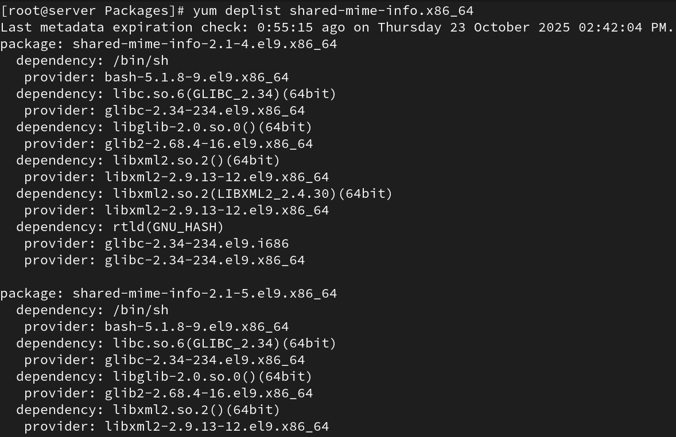

* How can you install a package group using Yum?

Use 'yum groupinstall "Group Name"'.

## Yum Repositories in Linux

* What is a Yum repository in Linux?

A storage location that contains RPM packages for Yum.

* How can you configure a custom Yum repository in Linux?

Create a .repo file under /etc/yum.repos.d/.

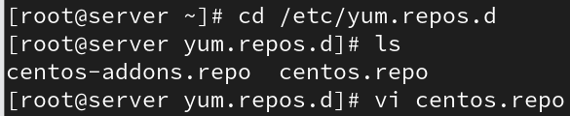

* What is the purpose of the baseurl directive in a Yum repository configuration?

It defines the path or URL to the repository source.

* How can you remove a Yum repository from the system?

Delete its .repo file from /etc/yum.repos.d/.



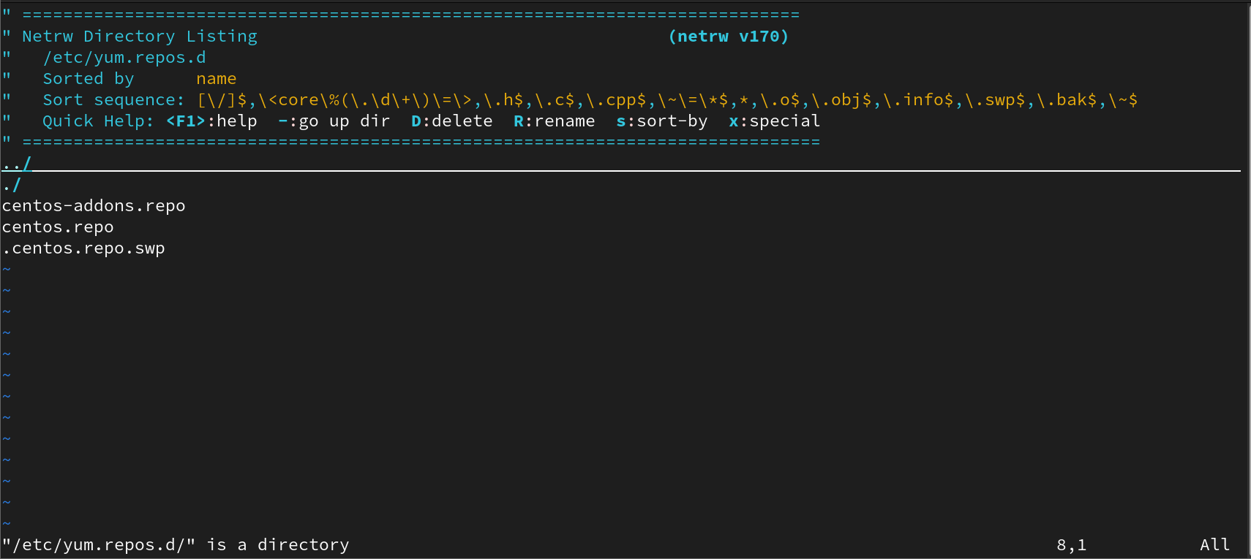

* What is the role of the yum.repos.d directory in Yum repositories?

It stores all Yum repository configuration files.

* What command is used to synchronize the metadata of a Yum repository?

Use 'yum makecache'.

* What are some common Yum repository management commands in Linux?

yum repolist, yum clean all, yum makecache.

## 16. SSH in Linux

* What is SSH?

SSH (Secure Shell) is a protocol for securely accessing remote systems.

* Port number of SSH?

Default SSH port is 22.

* Is it possible to change SSH port number?

Yes, by editing /etc/ssh/sshd_config.



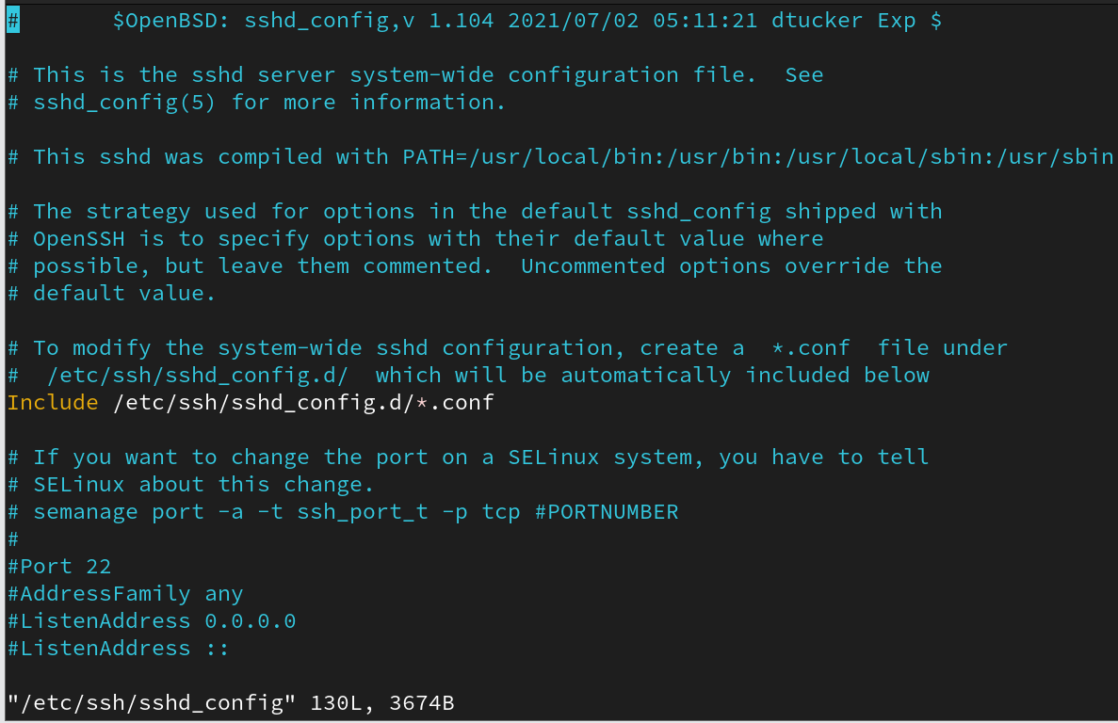

* Write command to login remote machine in terminal?

ssh user@hostname

* Write command to login local machine in terminal?

ssh localhost

* SSH configuration file location?

/etc/ssh/sshd_config

* Configure SSH key based authentication? write path of key file location? server1-user:admin1 to server2-user:admin1

Generate key with ssh-keygen, copy to ~/.ssh/authorized_keys on remote server.

* What is the command to generate the SSH key?

ssh-keygen

* What is the command to copy the keys to remote machine?

ssh-copy-id user@remote_host

* When you generate the key what are files will be created?

id_rsa (private) and id_rsa.pub (public).

* What is the SSH daemon name?

sshd

* Write SSH service-related commands which you know?

systemctl start|stop|restart|status sshd

* Disable SSH root login?

Edit /etc/ssh/sshd_config and set 'PermitRootLogin no'.

* How to disable password-based authentication?

Set 'PasswordAuthentication no' in sshd_config.

* Allow SSH access to particular user? (user1, user2, user3)

Add 'AllowUsers user1 user2 user3' in sshd_config.

* Change SSH port number 4044 and try to SSH login.

Edit sshd_config Port 4044 and restart sshd.

* How to start, stop, restart, check the status of SSH service?

systemctl start|stop|restart|status sshd

* How to start the SSH service permanently?

Enable at boot using 'systemctl enable sshd'.

* How to stop the SSH service permanently?

Disable it using 'systemctl disable sshd'.

## 17. Analyzing and Storing Logs in Linux

* What is the purpose of log files in Linux?

Log files record system, application, and user activity, helping administrators monitor and troubleshoot issues.

* How can you view the contents of a log file in Linux?

You can use commands like `cat`, `less`, `more`, or `tail` to view log contents. Example: `less /var/log/messages`.

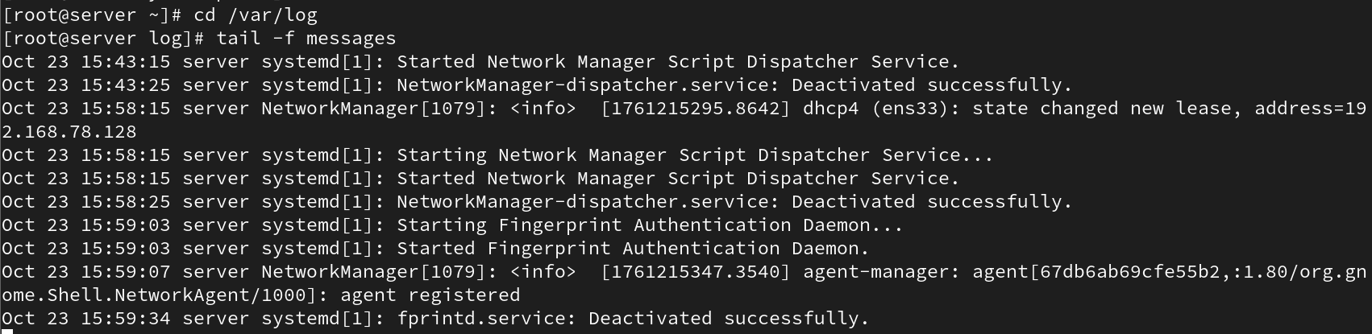

* What command is used to search for specific keywords or patterns within a log file?

Use the `grep` command. Example: `grep error /var/log/messages`.

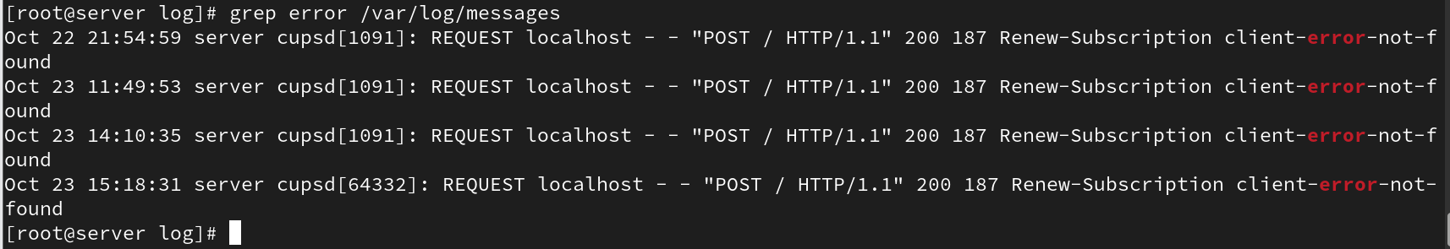

* How can you filter log entries based on specific criteria using the grep command?

You can combine `grep` with options like `-i` for case-insensitive search or `-E` for regular expressions. Example: `grep -i failed /var/log/secure`.



* What is the purpose of log rotation in Linux?

Log rotation prevents log files from growing indefinitely by compressing and archiving old logs automatically.

* How can you configure log rotation for a specific log file?

Edit or create configuration files in `/etc/logrotate.d/` and define rotation rules for that log file.

* What is the significance of log levels in log files?

Log levels (e.g., info, warning, error, critical) indicate the severity of events to help prioritize troubleshooting.

* How can you analyze logs for errors and warnings using regular expressions?

Use `grep -E 'error|warning' /var/log/messages` to find matching entries.

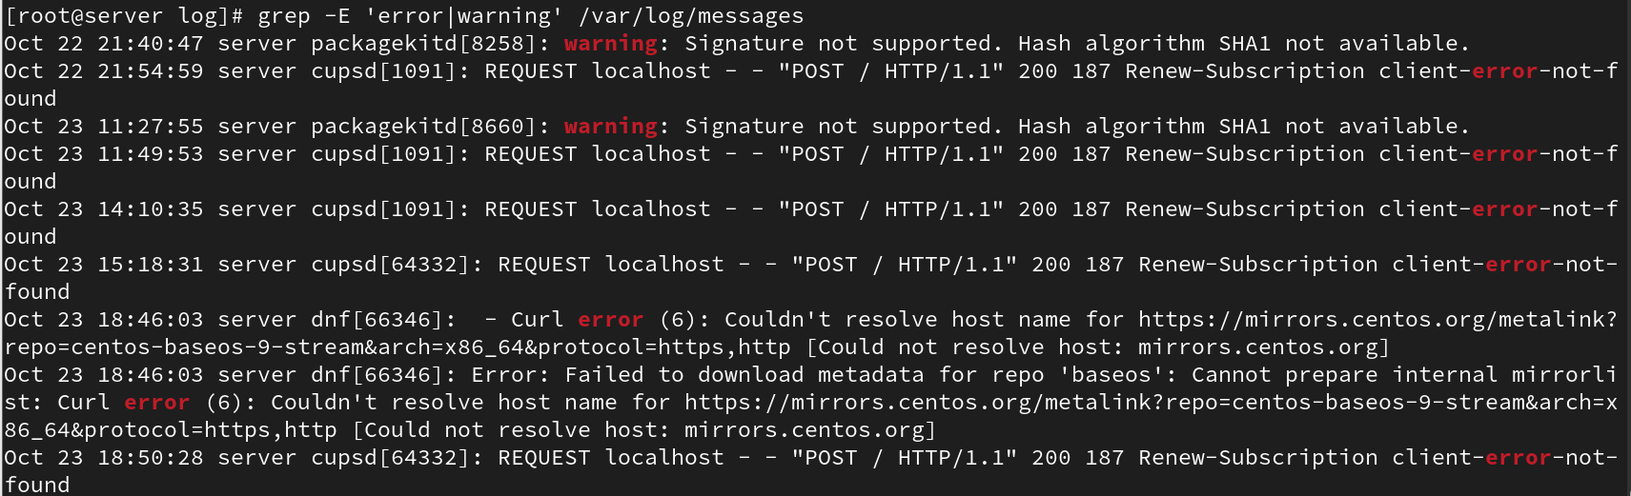

* What are some commonly used log files in Linux?

/var/log/messages, /var/log/secure, /var/log/cron, /var/log/dmesg, /var/log/httpd/.

* How can you monitor log files in real-time using the tail command?

Use `tail -f /var/log/messages` to continuously watch new log entries.

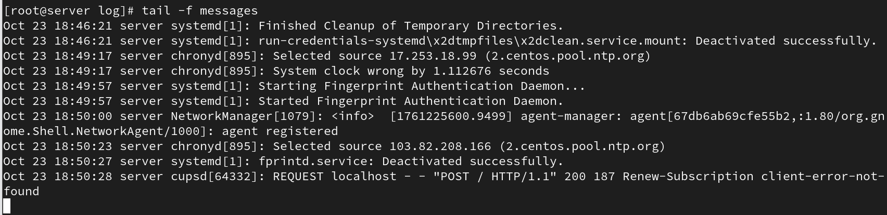

* What is the purpose of log analyzers and monitoring tools in Linux?

Tools like `journalctl`, `logwatch`, help visualize, filter, and analyze logs efficiently.

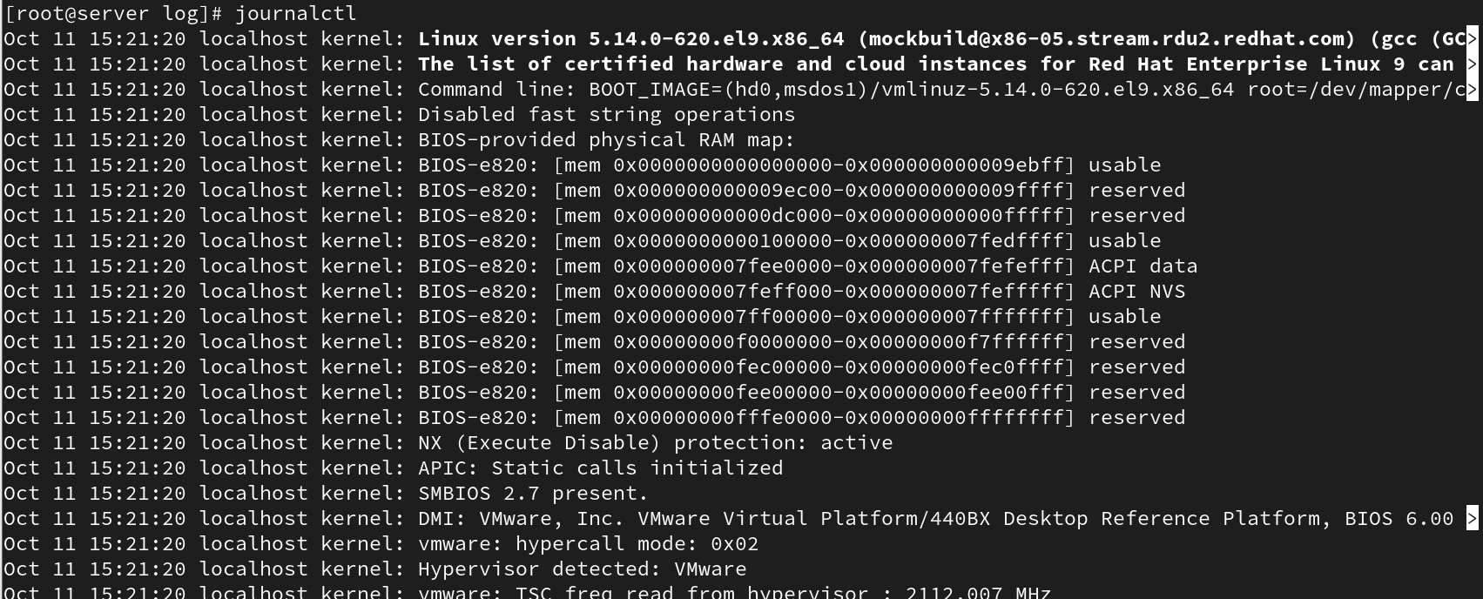

* How can you store logs remotely using a centralized logging server?

By configuring `rsyslog` or `syslog-ng` to send logs to a remote log server using TCP/UDP.

* What is the role of the /var/log directory in Linux?

It stores all system and service log files used for auditing and troubleshooting.

## 18. Access Control Lists (ACL)

* Set a read and write ACL for user bob on the file /home/user1/report.txt.

Command: `setfacl -m u:bob:rw /home/user1/report.txt`.

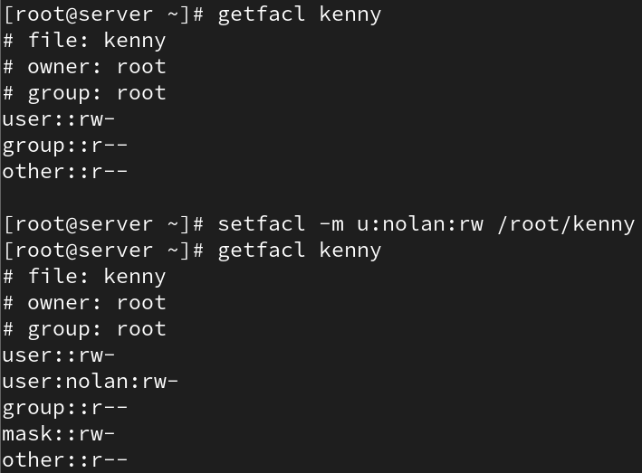

* Remove all ACL entries for the file /var/log/syslog.

Command: `setfacl -b /var/log/syslog`.

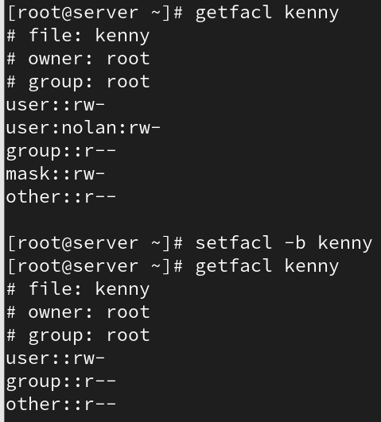

* Grant the group developers read, write, and execute permissions on the directory /home/projects/, including all files and subdirectories.

Command: `setfacl -R -m g:developers:rwx /home/projects/`.

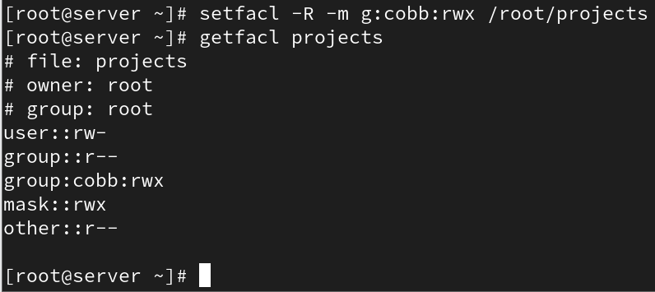

* Set a default ACL that gives the group marketing read-only access to all new files created in the directory /shared/marketing/.

Command: `setfacl -d -m g:marketing:r /shared/marketing/`.

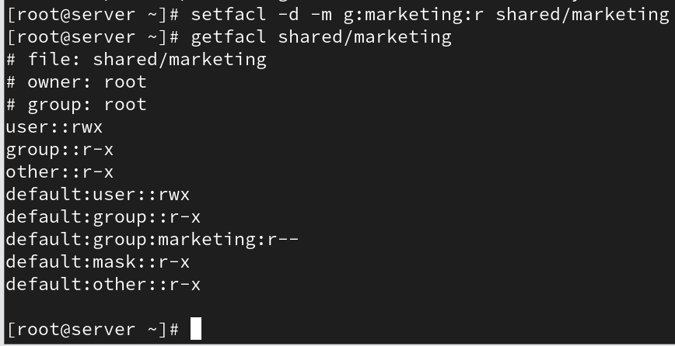

* Check and display all the ACL entries on the file /etc/hosts.

Command: `getfacl /etc/hosts`.

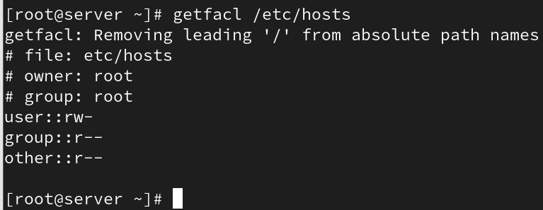

* Set the user alice to have no permissions on the file /home/user2/confidential.txt, even though she belongs to the users group which has permissions.

Command: `setfacl -m u:alice:--- /home/user2/confidential.txt`.

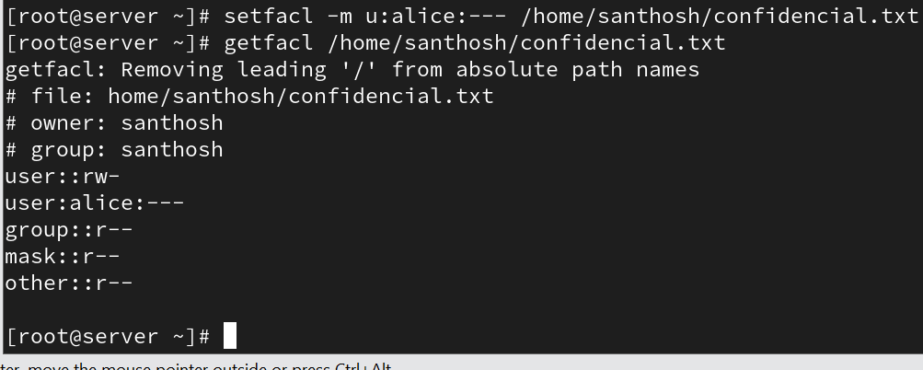

* Grant the user tom execute permission on the directory /scripts/ and all files inside it.

Command: `setfacl -R -m u:tom:x /scripts/`.

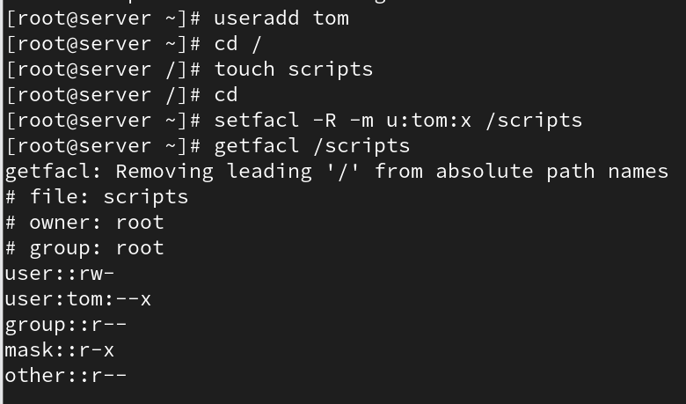

* Modify the ACL of the file /data/project.txt to grant the user susan read and write permissions, but not execute permissions.

Command: `setfacl -m u:susan:rw /data/project.txt`.

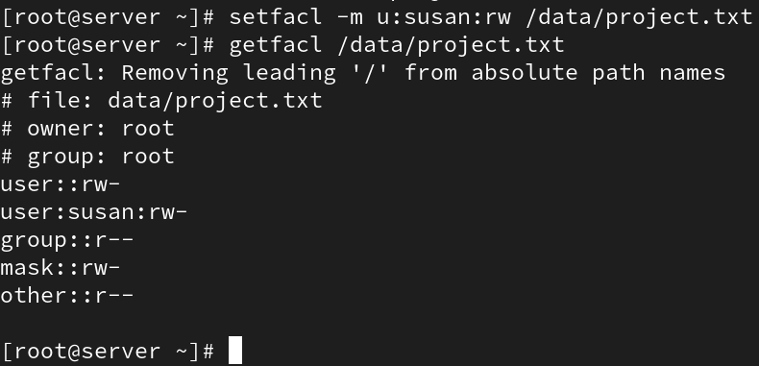

* Set an ACL for the group admin to have full permissions (read, write, execute) on the file /etc/passwd, while keeping the original permissions for other users intact.

Command: `setfacl -m g:admin:rwx /etc/passwd`.

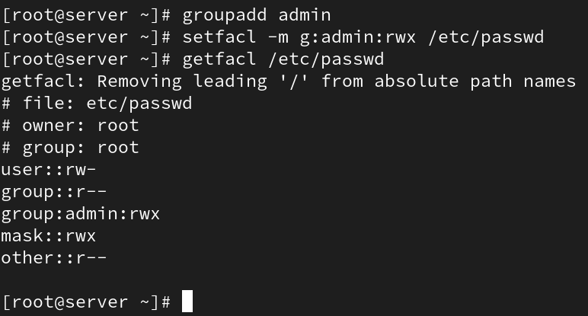

* Create an ACL that removes write permissions for the group staff on the file /tmp/notes.txt, but allows the owner to retain full permissions.

Command: `setfacl -m g:staff:r-x /tmp/notes.txt`.

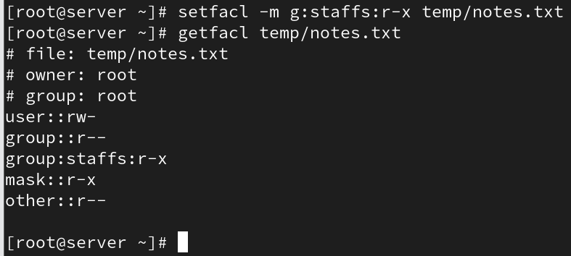

## Network Configuration

* Add additional ethernet card and assign static ip

Use `nmcli` or edit network scripts. Example:  
`nmcli con add type ethernet ifname eth1 ip4 192.168.1.10/24 gw4 192.168.1.1`.

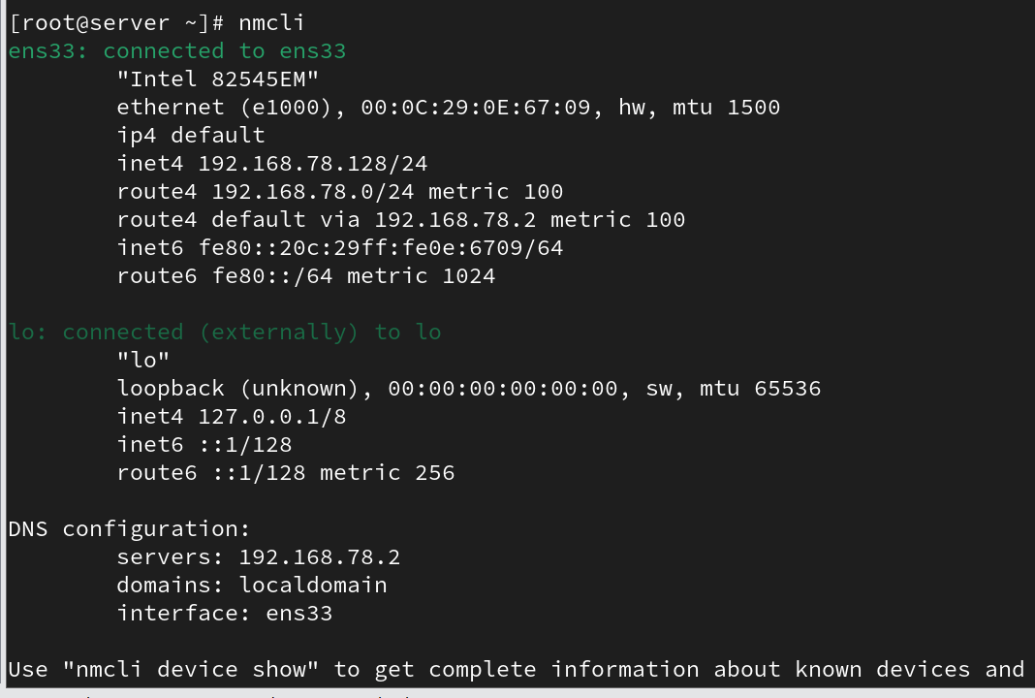

* Add additional ethernet card and assign dynamic ip

Use DHCP: `nmcli con add type ethernet ifname eth1`.



* How to check the server IP also show the current IP details?

Use `ip addr show` or `ifconfig`.

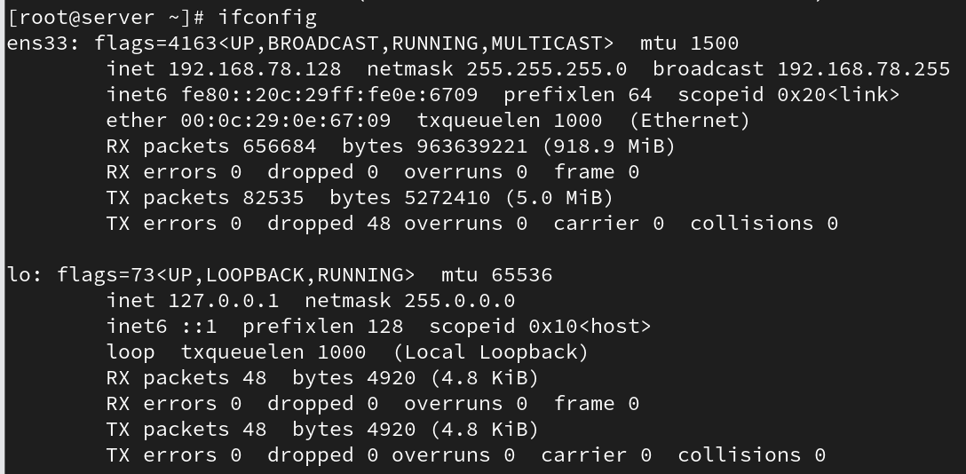

* How to check the server routes also show current route details?

Use `ip route show` or `route -n`.

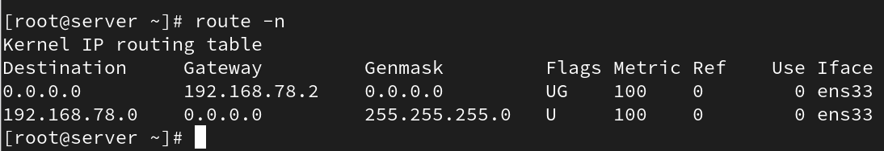

* Add two ethernet card and assign one ip?

Configure bonding or teaming using `/etc/sysconfig/network-scripts/ifcfg-bond0`.

* Assign two ip address for one Ethernet card?

Use `ip addr add 192.168.1.11/24 dev eth0` for the second IP.

* How to check the server hostname

Use `hostname` or `hostnamectl`.

* Change server hostname as server.glotechcorp.com permanently

Use `hostnamectl set-hostname server.glotechcorp.com` and update `/etc/hostname`.